**AMITY UNIVERSITY MAHARASHTRA**

**AMITY INSTITUTE OF INFORMATION TECHNOLOGY**

**DevOps**

**MCA – SEM I**



Name of the Student: **DHEERAJ KUMAR**

Program/Semester: **MCA / SEMESTER I**

Enrolment Number:  **A710145025004**

**AMITY UNIVERSITY MAHARASHTRA**

Established vide Maharashtra Act No.13 of 2014, of Government of Maharashtra, and recognized under Section 2 (f) of UGC Act 1956.

Amity Institute of Information Technology

**CERTIFICATE**

This is to certify that, Mr./Ms. ______________ Student of MCA Semester I (Batch 2025-27) has completed the ______________ during the academic year 2025-26, under the internal guidance of Prof. _____________.

Signed by Guide :

Date :

**INDEX**

|  |  |  |  |
| --- | --- | --- | --- |
| **SR No.** | **PRACTICAL** | **PAGE No.** | **REMARKS** |
| 01 | Source code Management using Git & GitHub, GitLab in Collaborative teaming, Store, marge, version control of the code |  |  |
| 02 | Lab on continuous Integration from different developers into a single piece of software using Jenkins. |  |  |
| 03 | Testing the application using Selenium |  |  |
| 04 | Testing the form using Selenium |  |  |
| 05 | Testing automation and HTML report generation using selenium |  |  |
| 06 | Containerization using Docker |  |  |

**Practical 1**

Source code Management using Git & GitHub, GitLab in Collaborative teaming, Store, marge, version control of the code

**Create new repo**

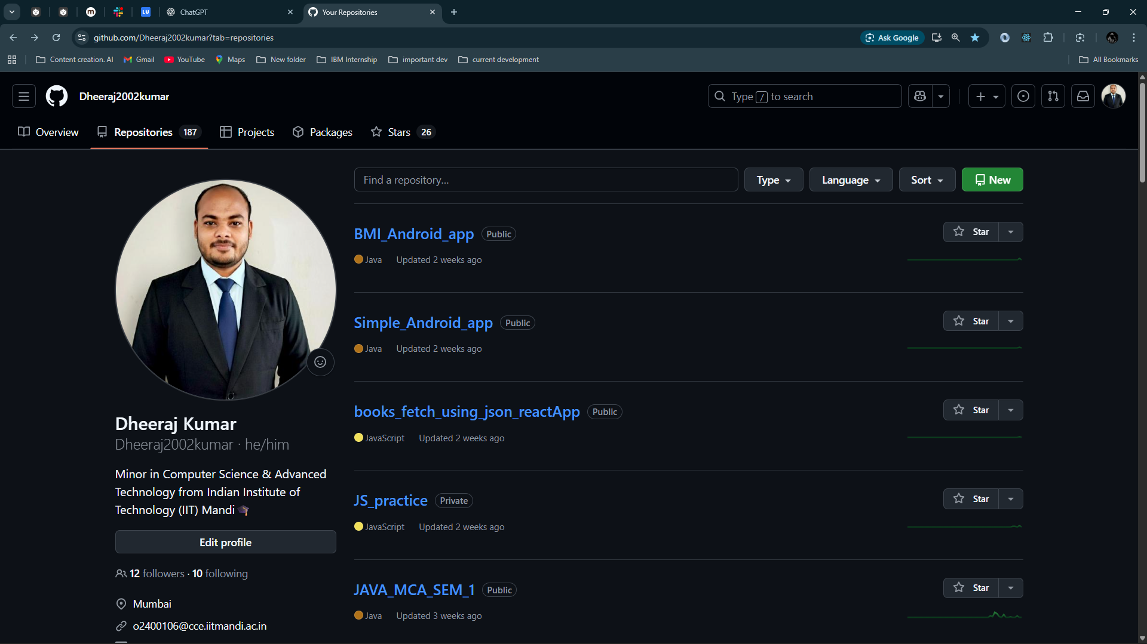

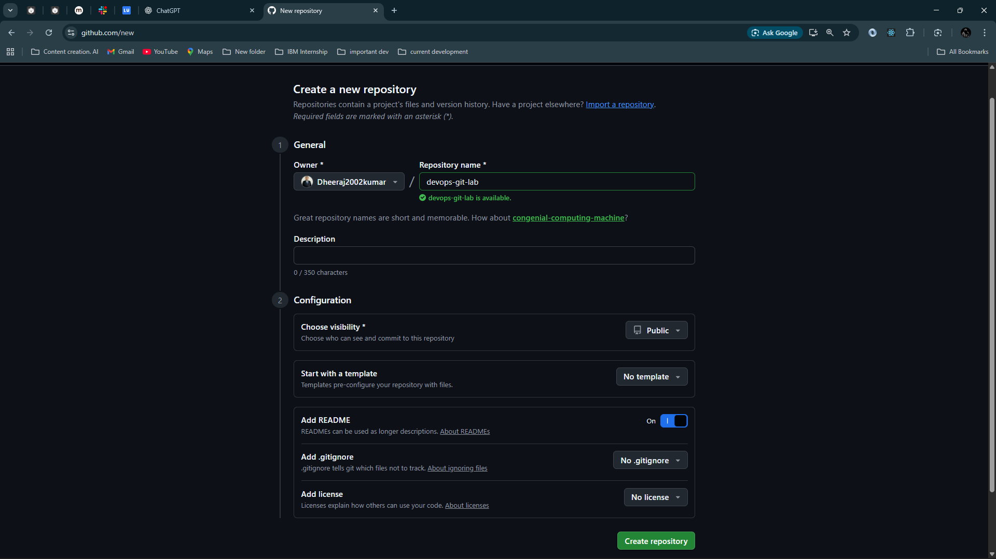 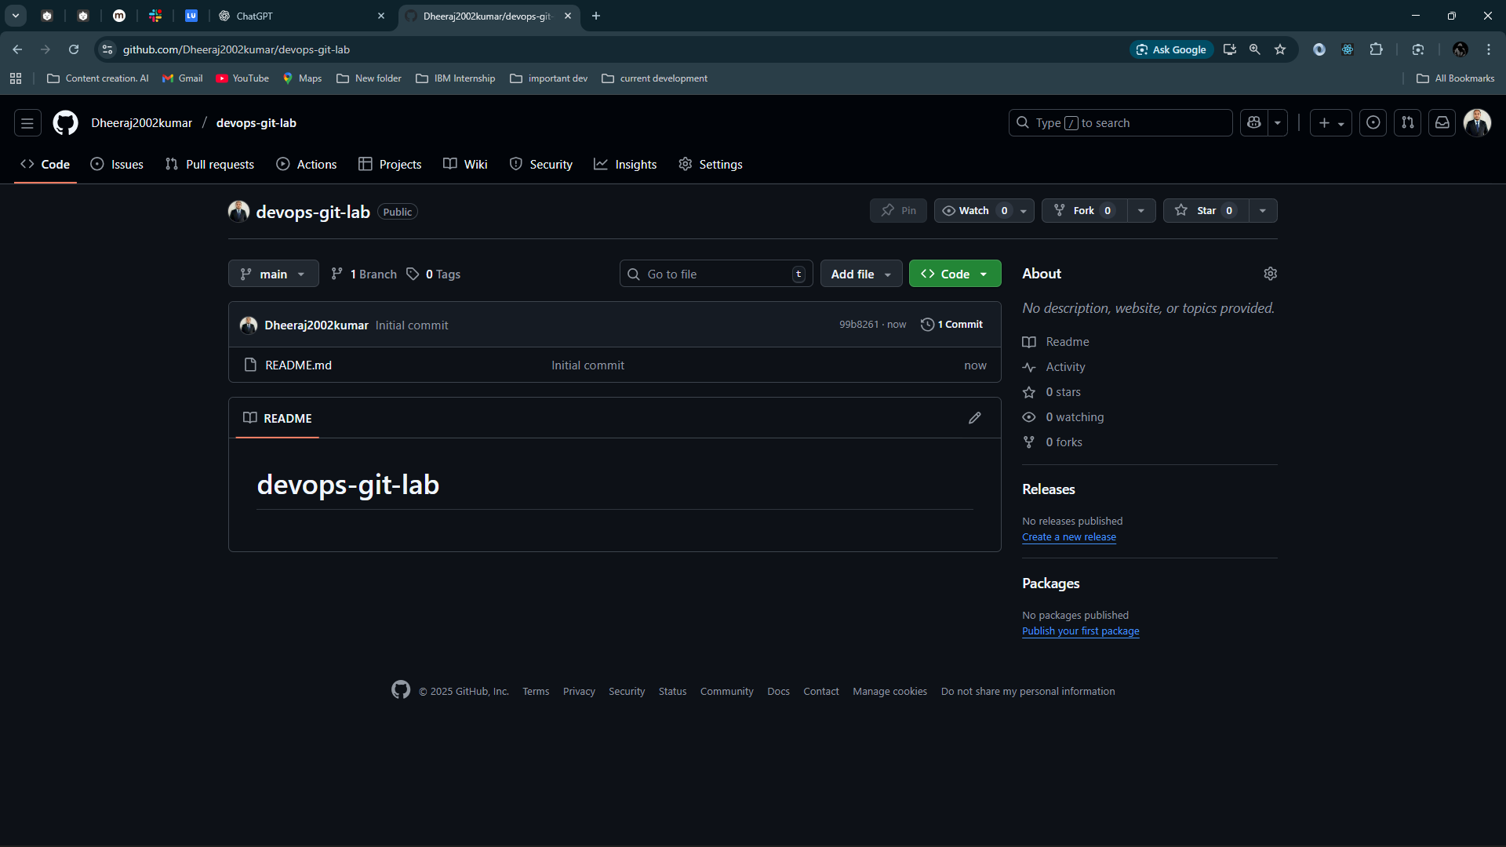

Copy the url and clone it

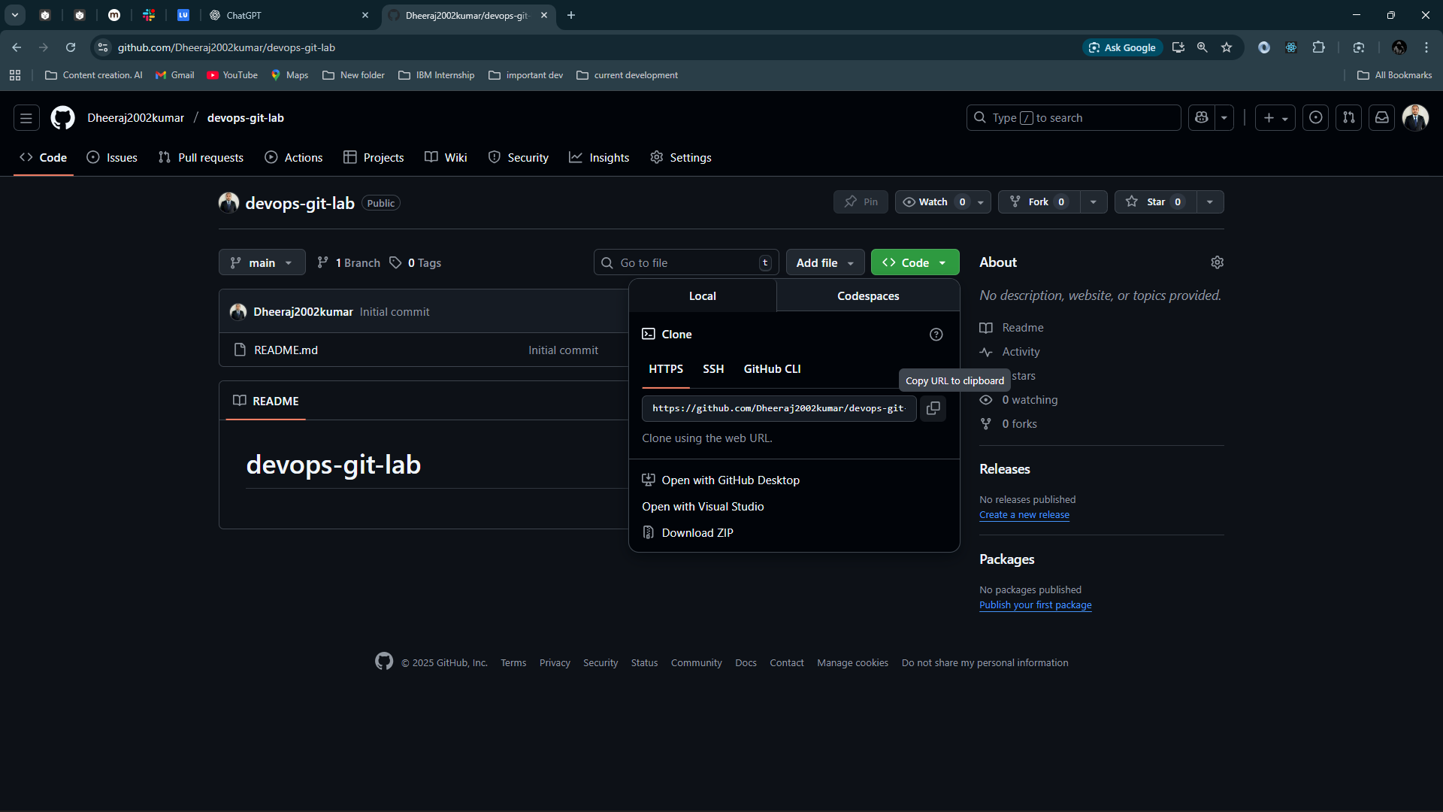

# ****Clone the Repository for Collaboration****

A collaborator would run:

git clone https://github.com/Dheeraj2002kumar/devops-git-lab.git

cd devops-git-lab

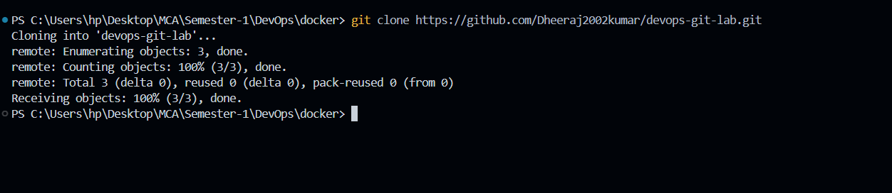

Create your sample file:

echo "This is test.txt for Git lab." > test.txt

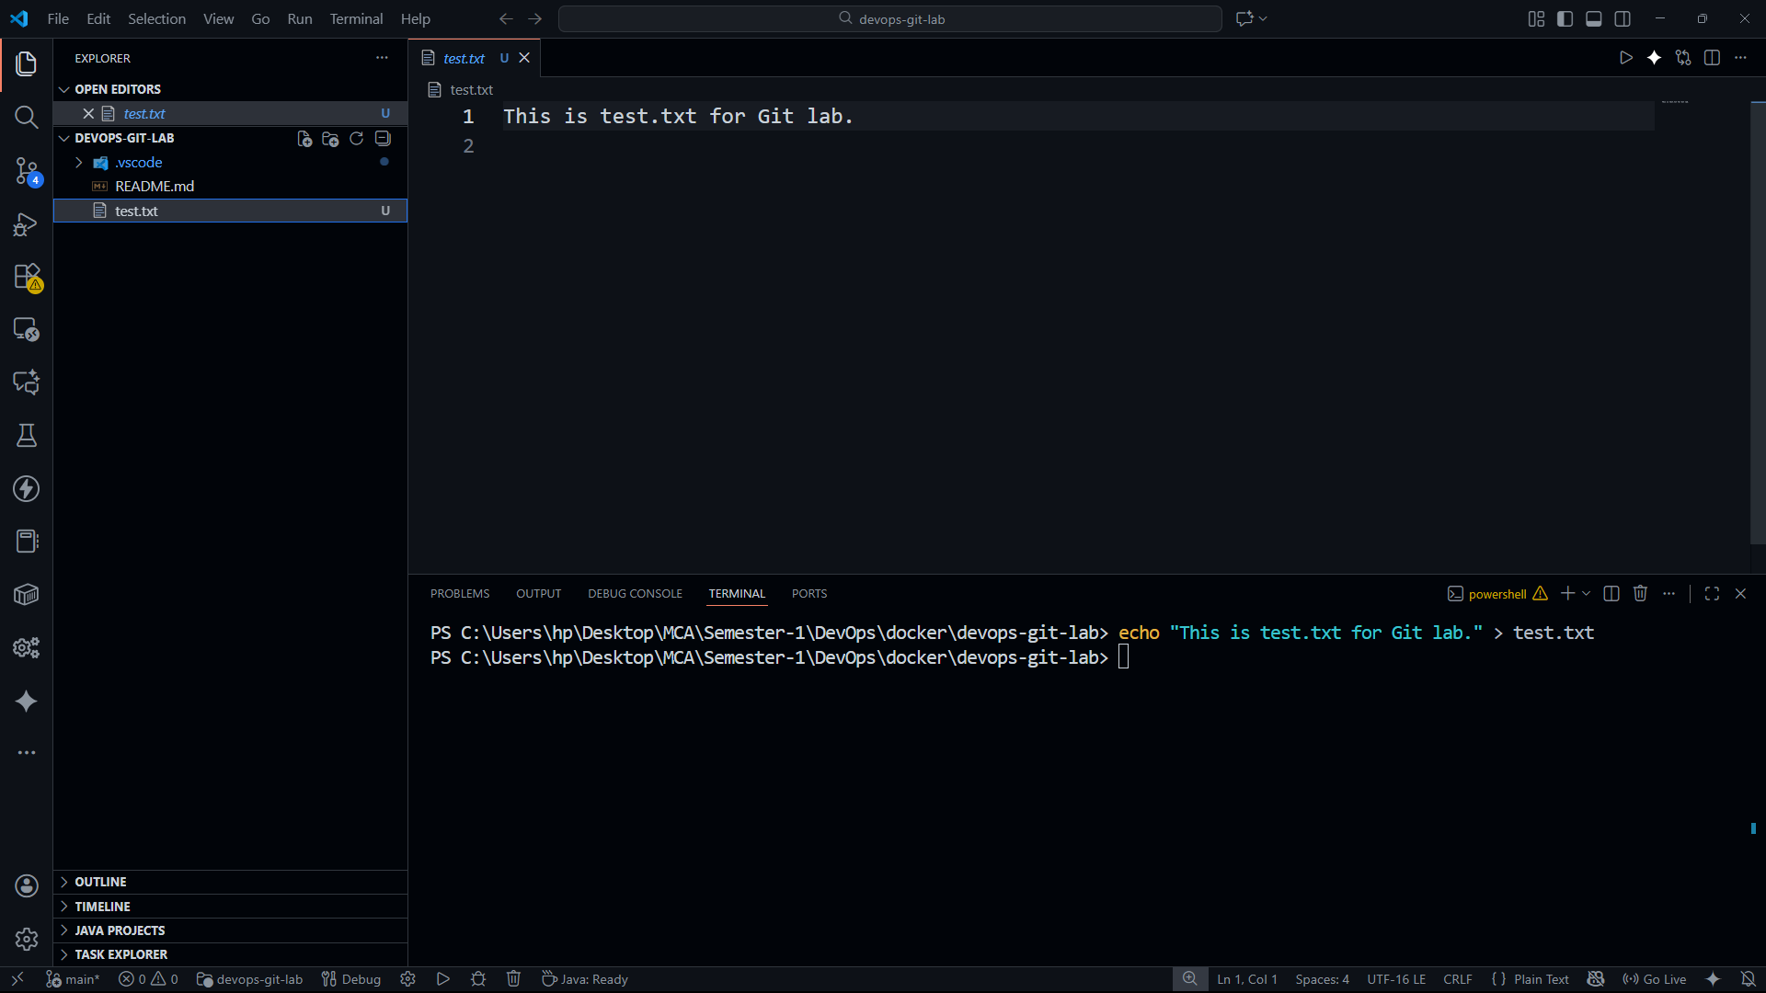

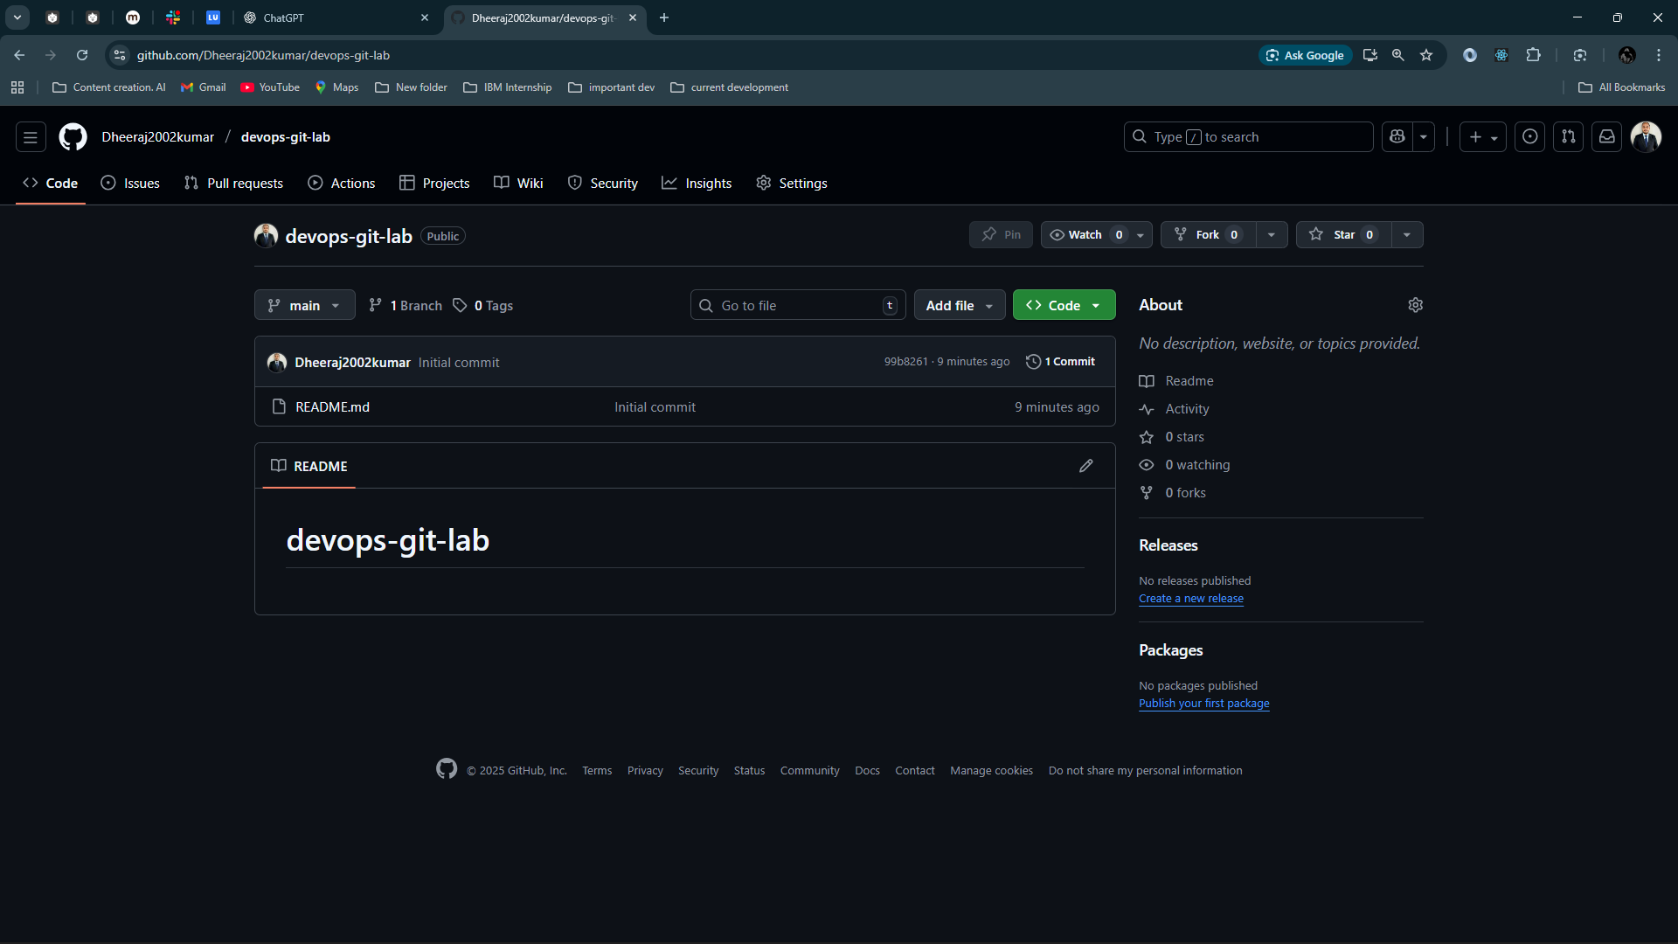

Push the code txt file in github

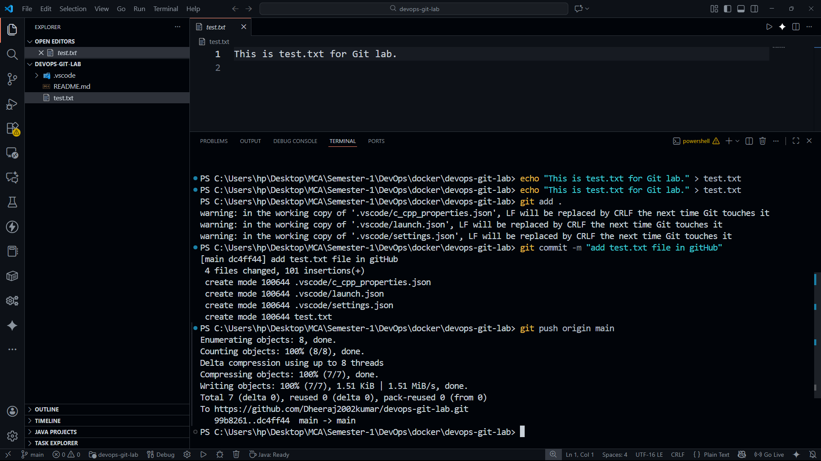

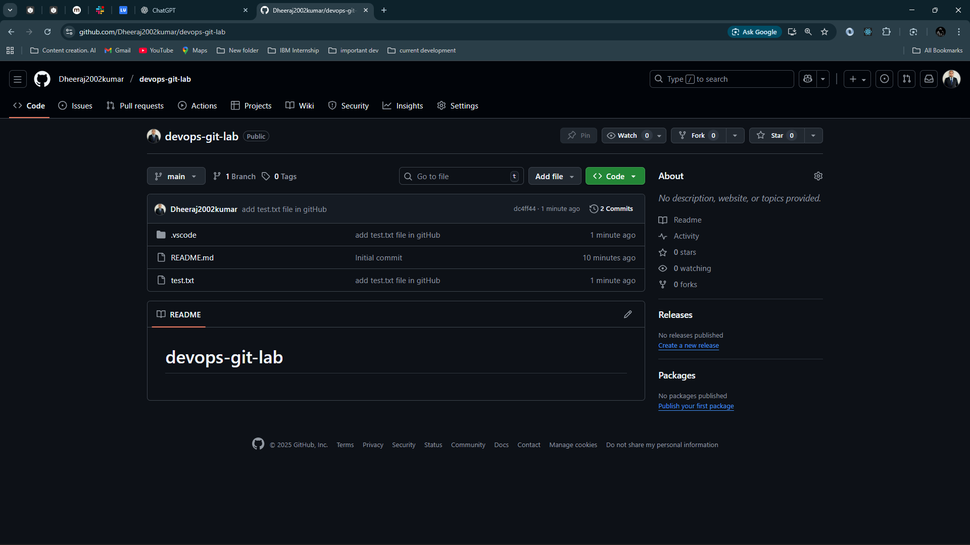

You can see the test.txt file

# ****Create a New Branch for Editing test.txt****

git checkout -b feature-update-testfile

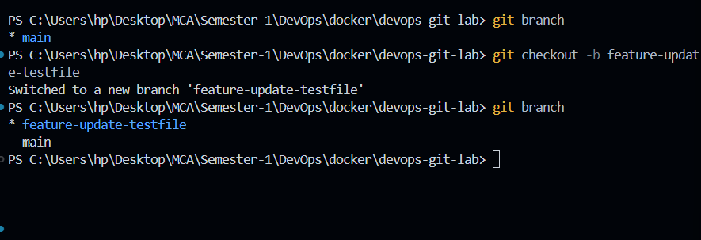

Modify the file:

echo "New update: Version 2" >> test.txt

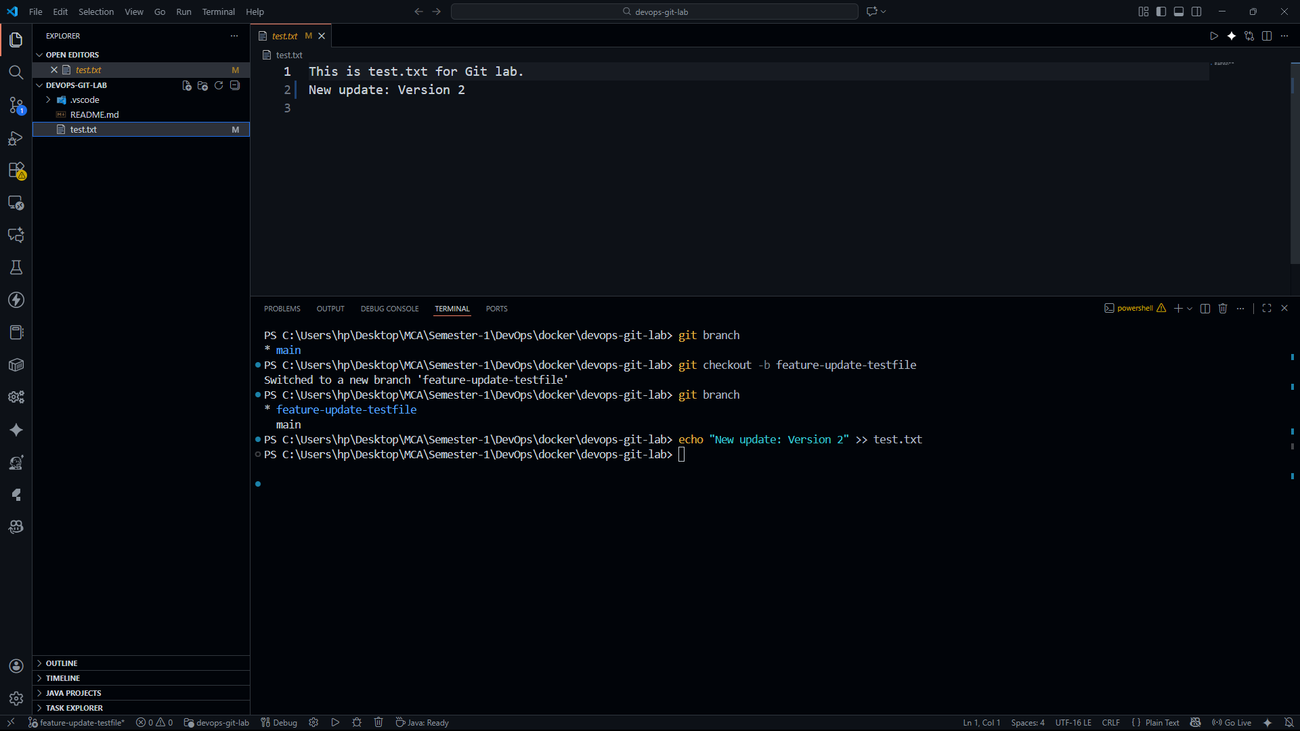

Stage and commit:

git add test.txt

git commit -m "Added version 2 update in test.txt"

Push the branch:

git push origin feature-update-testfile

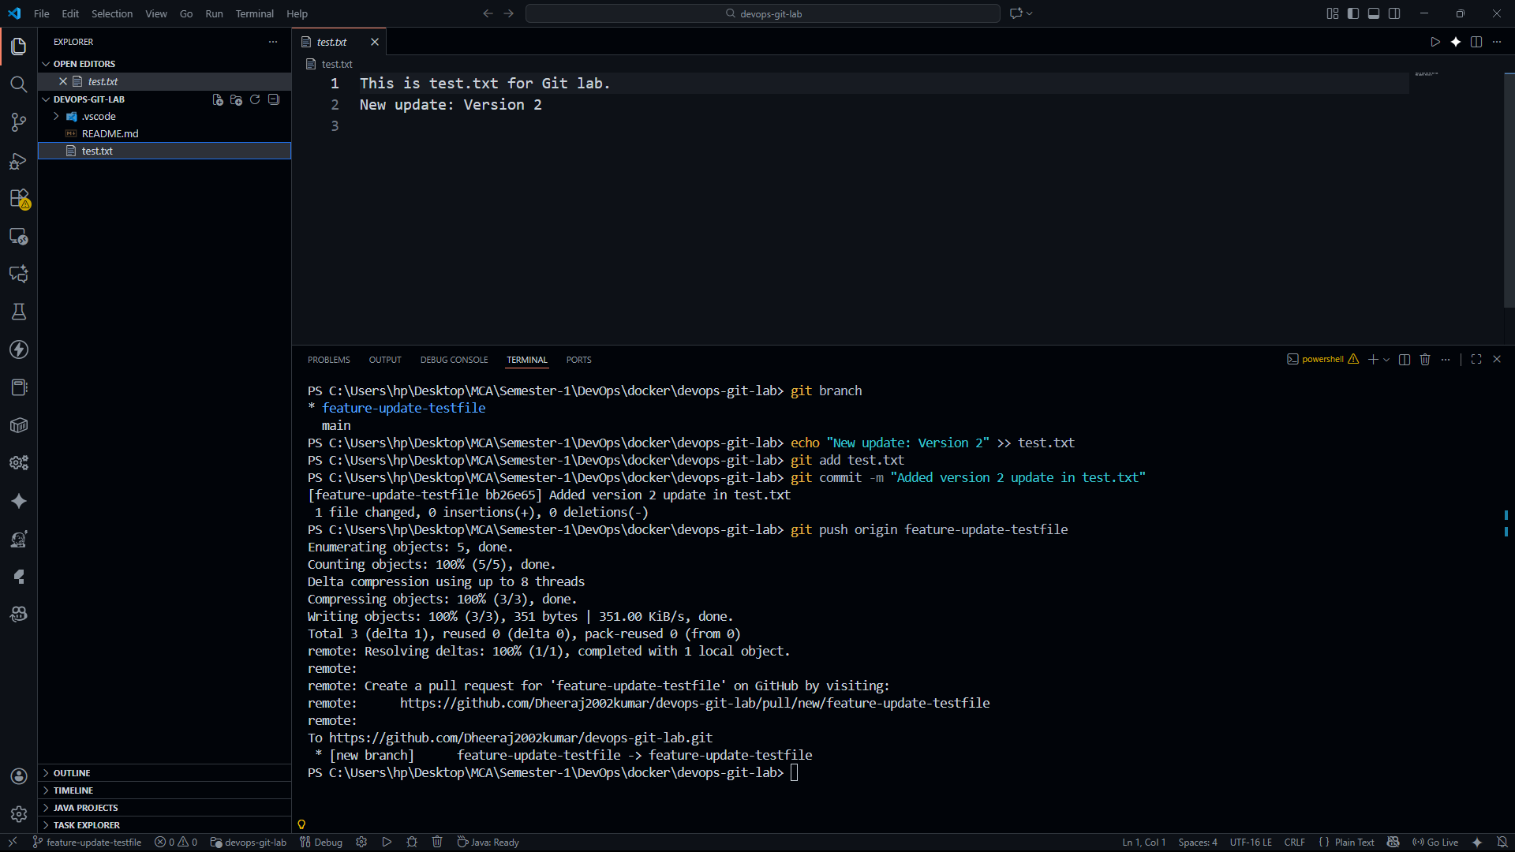

# ****Create a Pull Request (PR)****

In GitHub:

1. Open the repo
2. Click **Compare & Pull Request**
3. Add title: “Update test.txt to version 2”
4. Add description
5. Submit PR
6. Another team member reviews
7. Click **Merge Pull Request**

### Update your local repo after merge:

git checkout main

git pull origin main

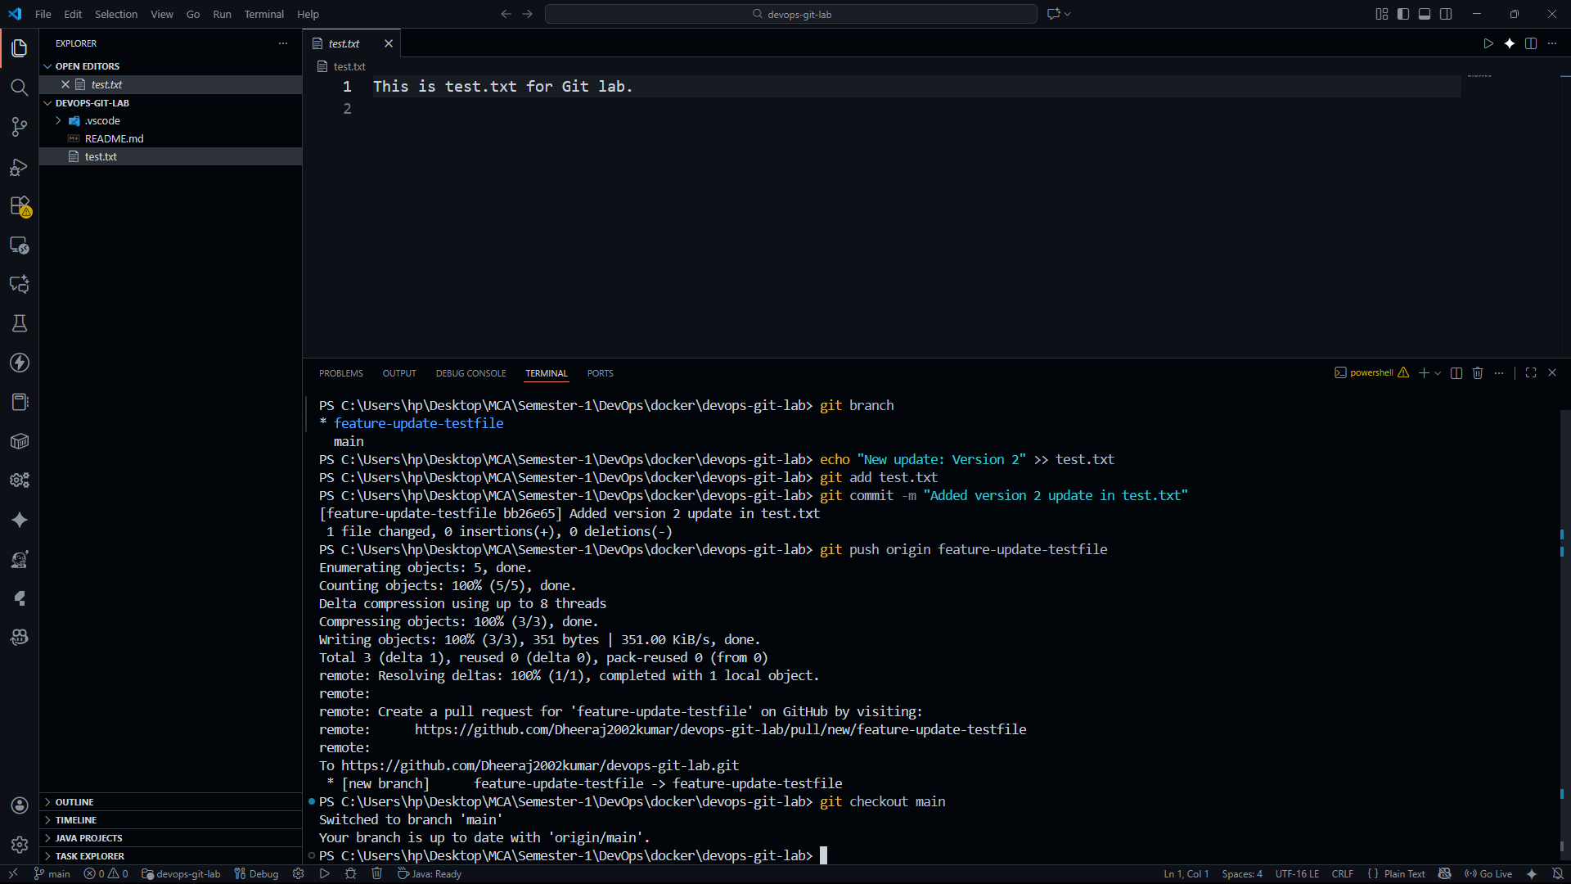

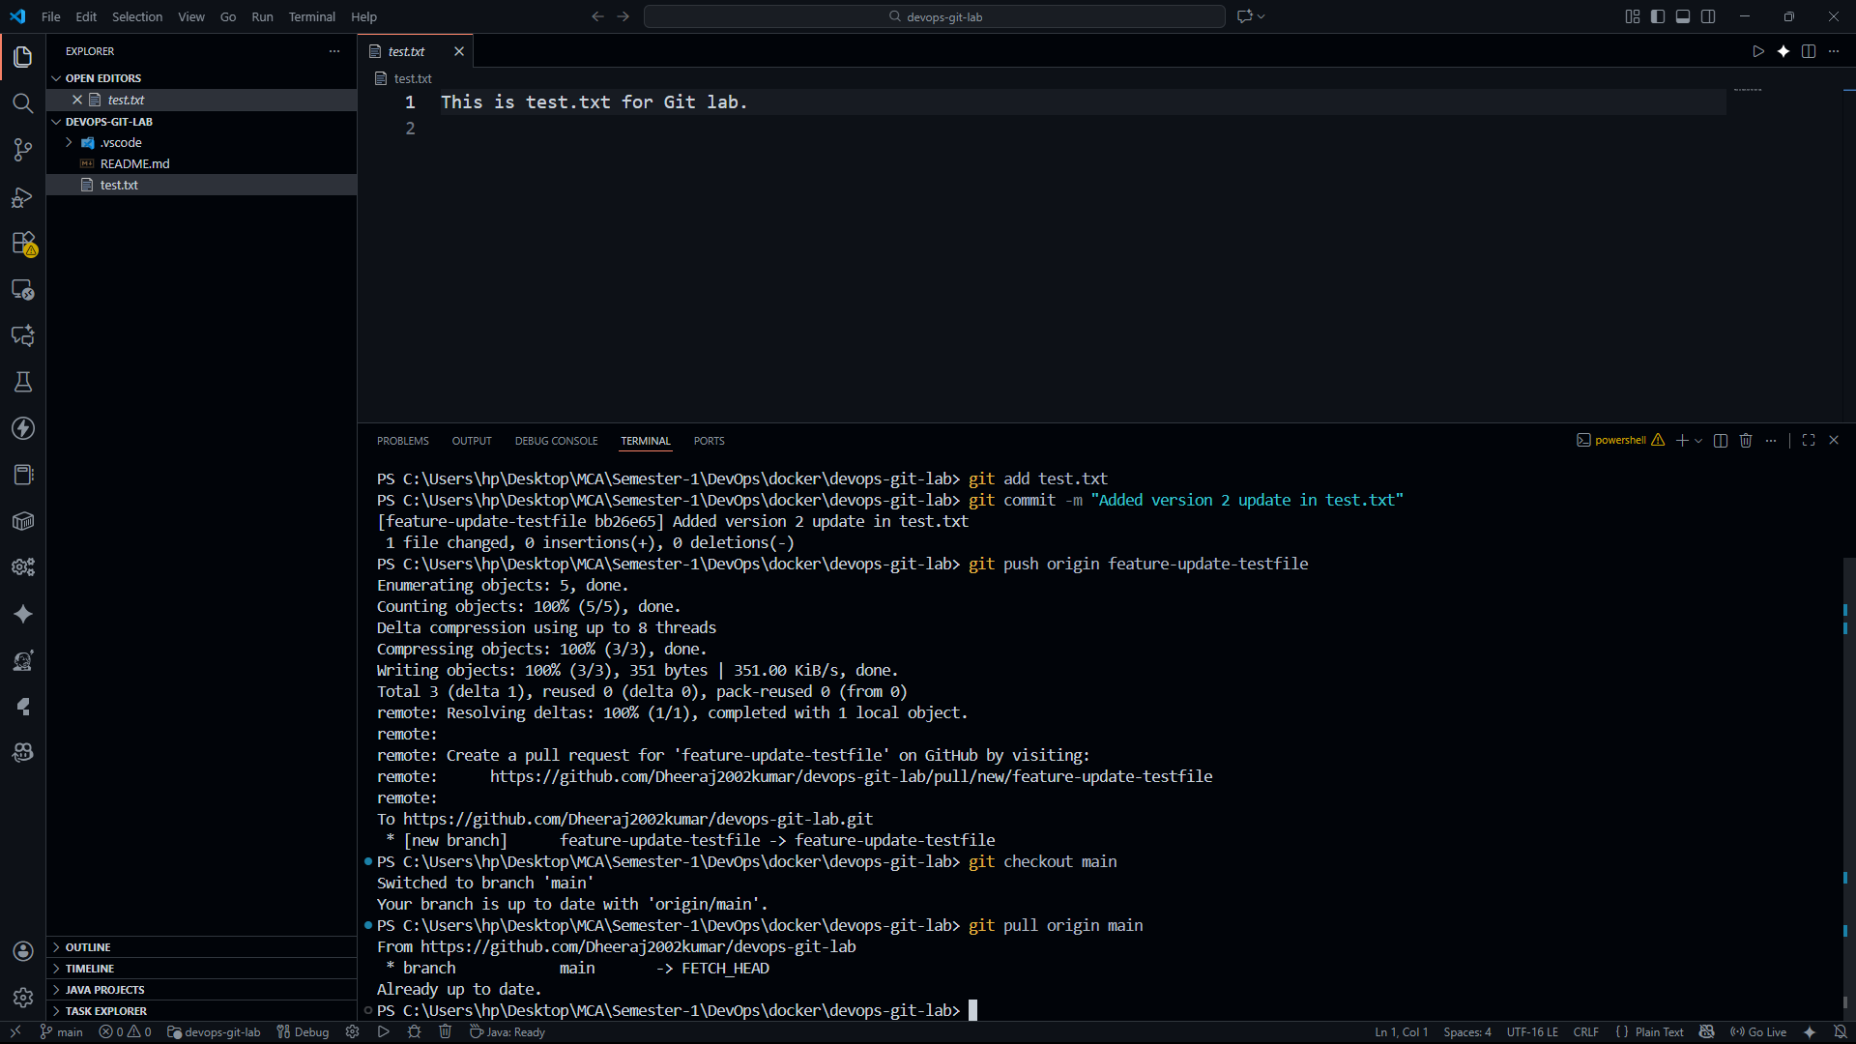

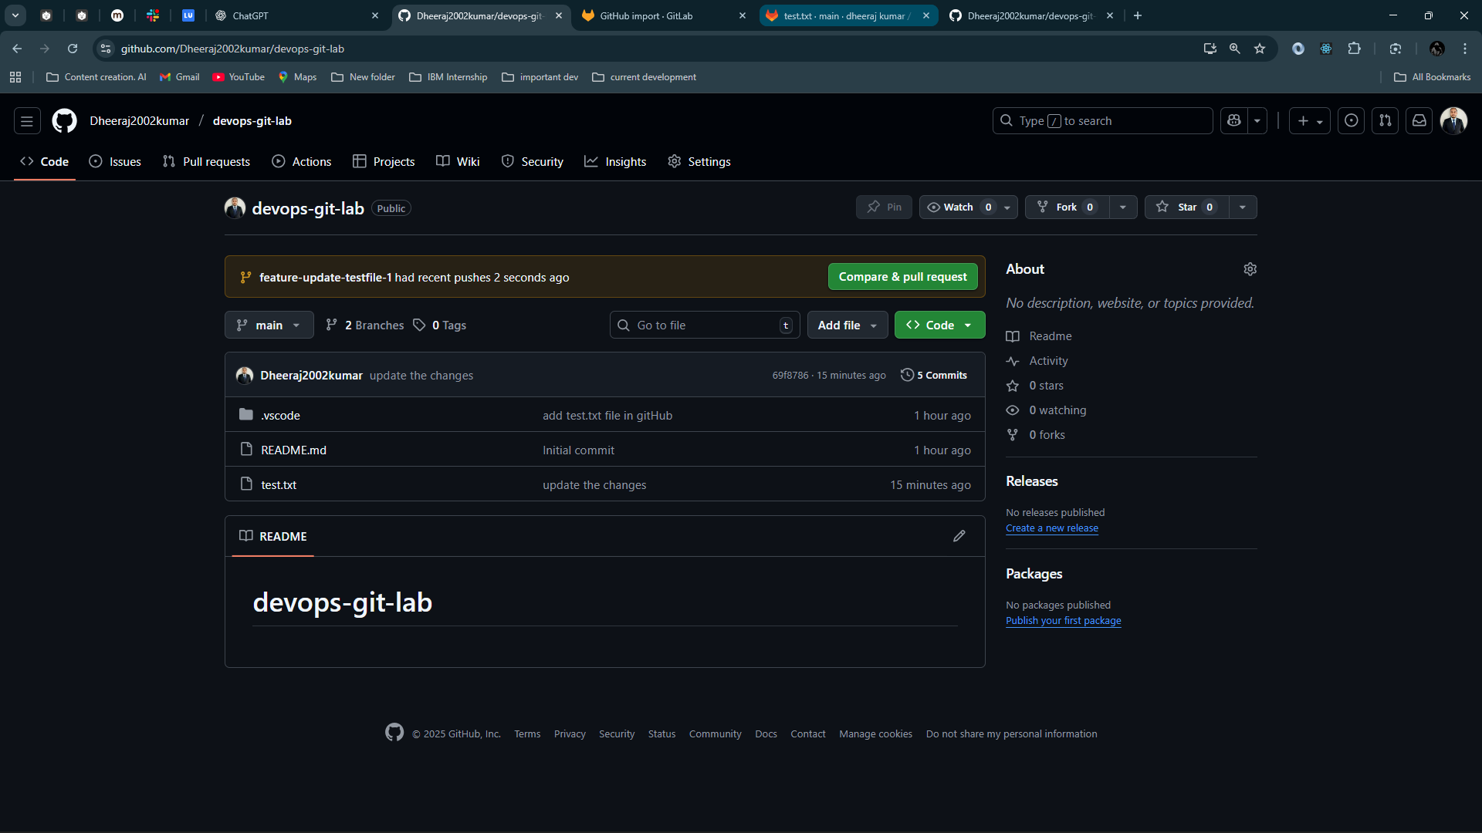

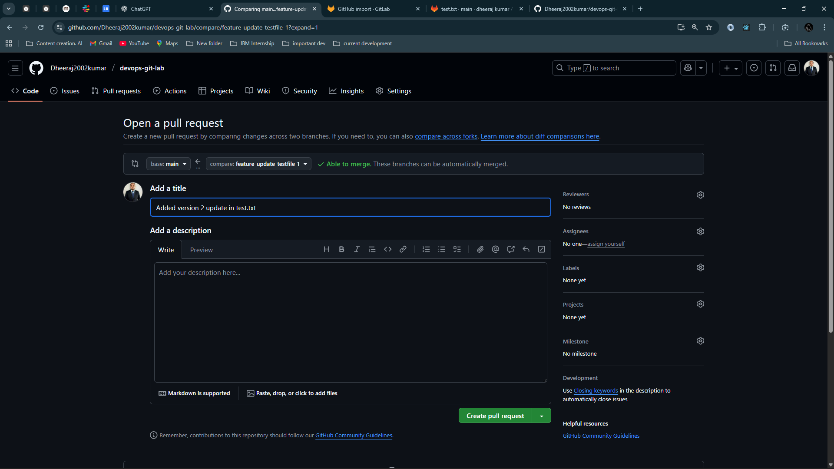

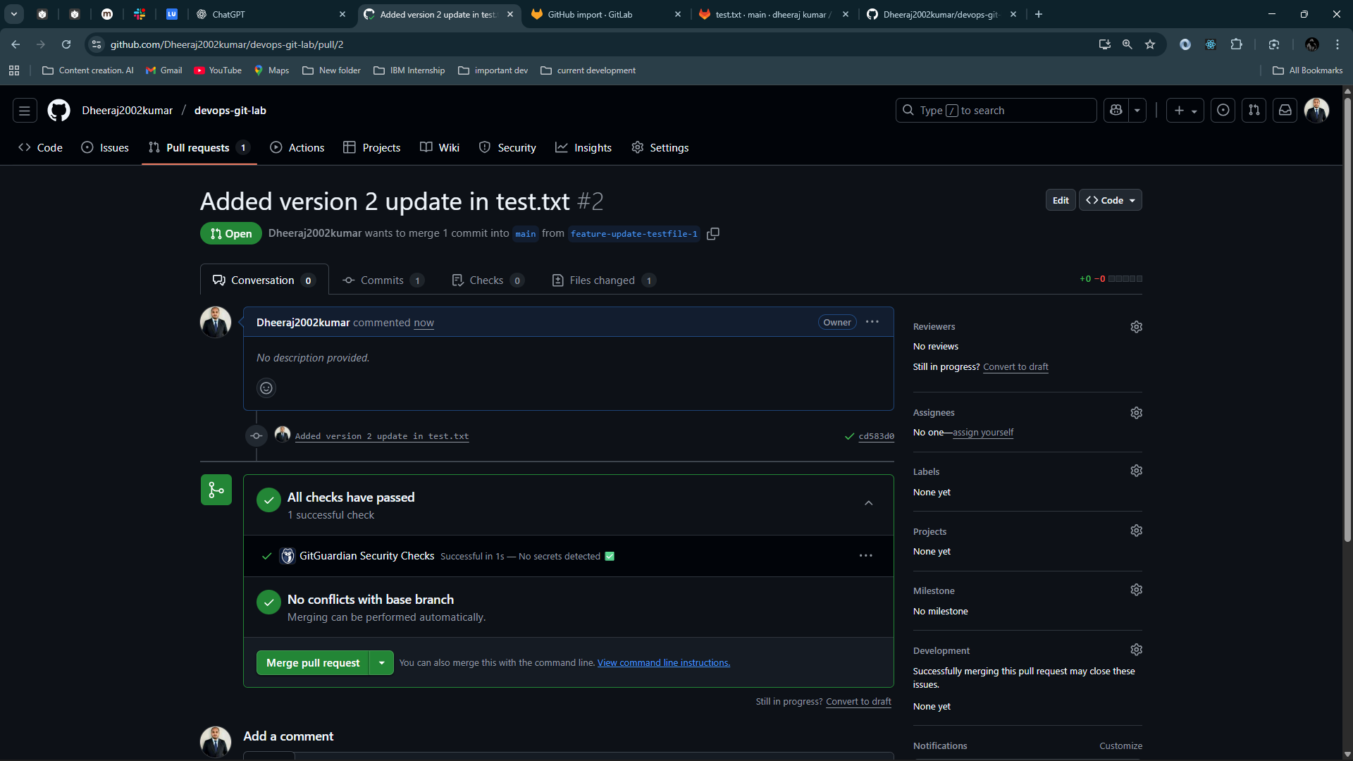

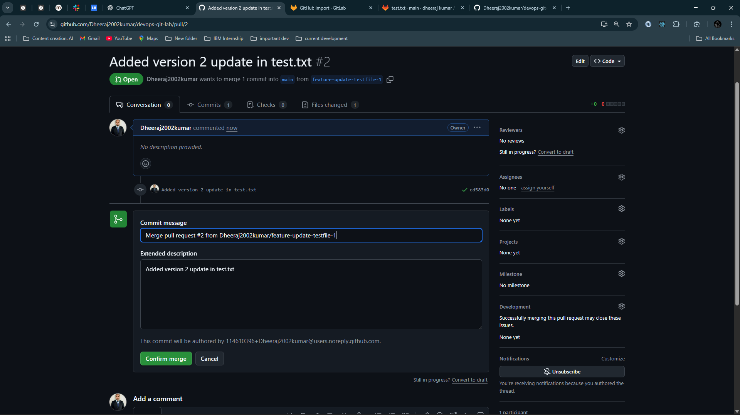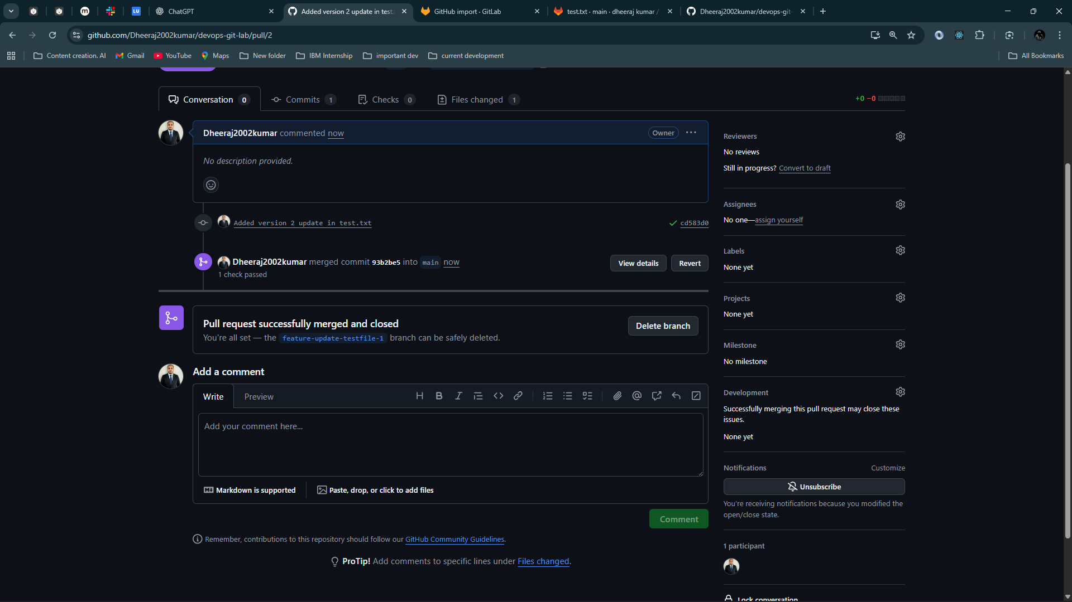

# ****Mirror GitHub Repository to GitLab****

### Create a GitLab repo:

* Go to <https://gitlab.com> → New Project → **Import from GitHub**

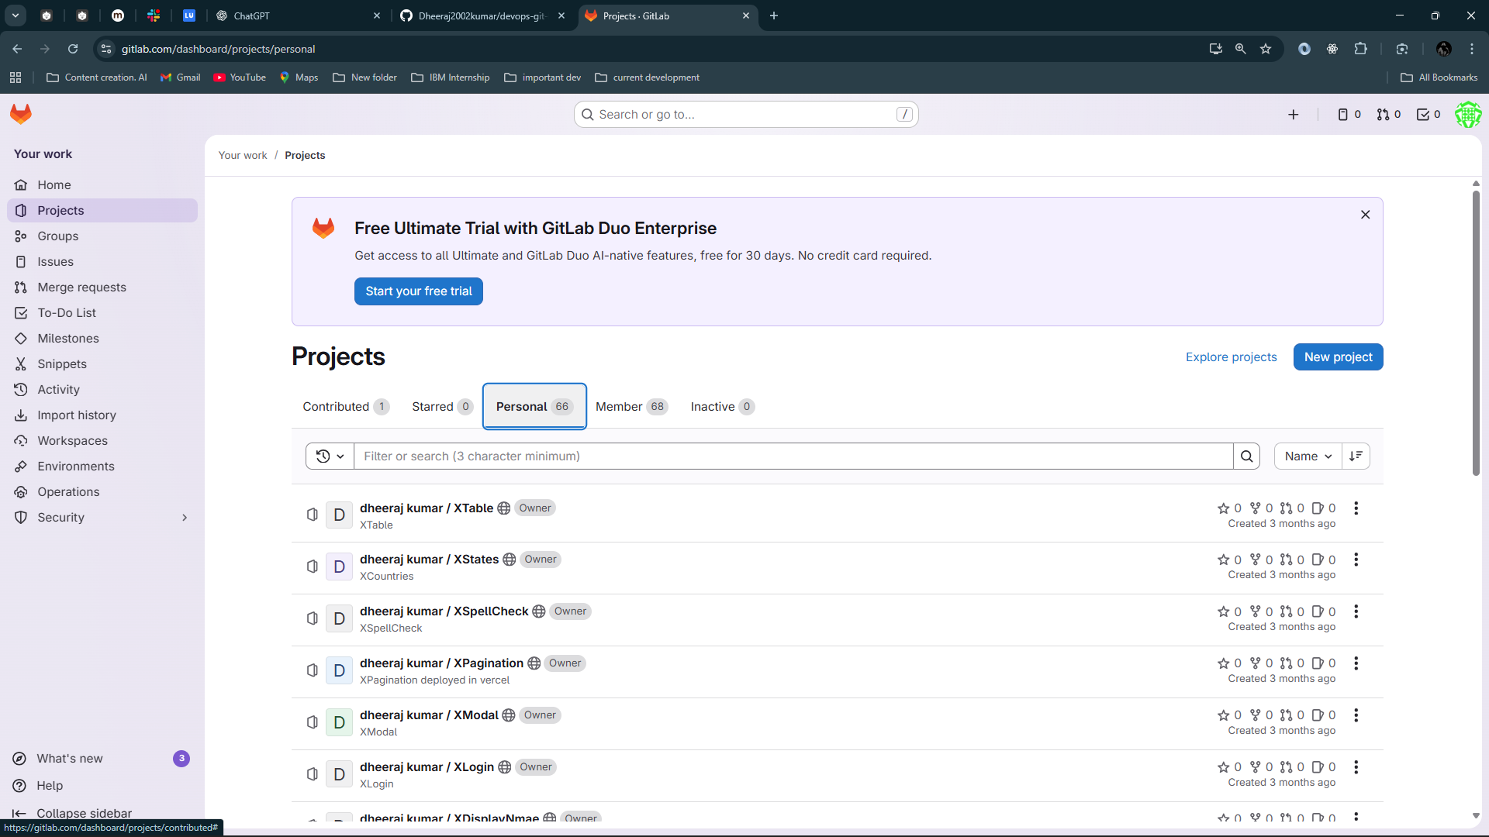

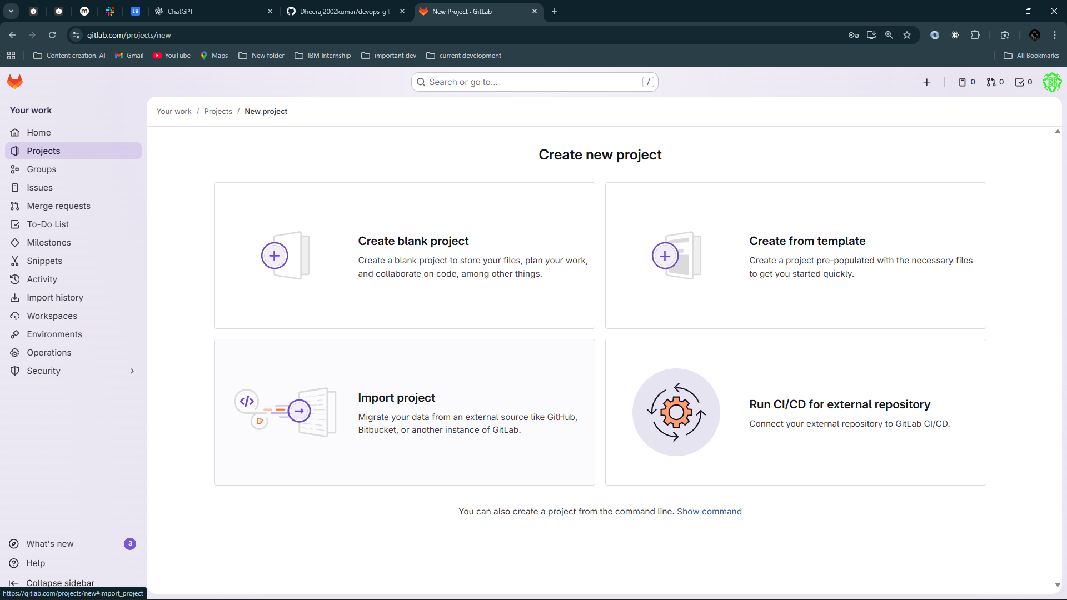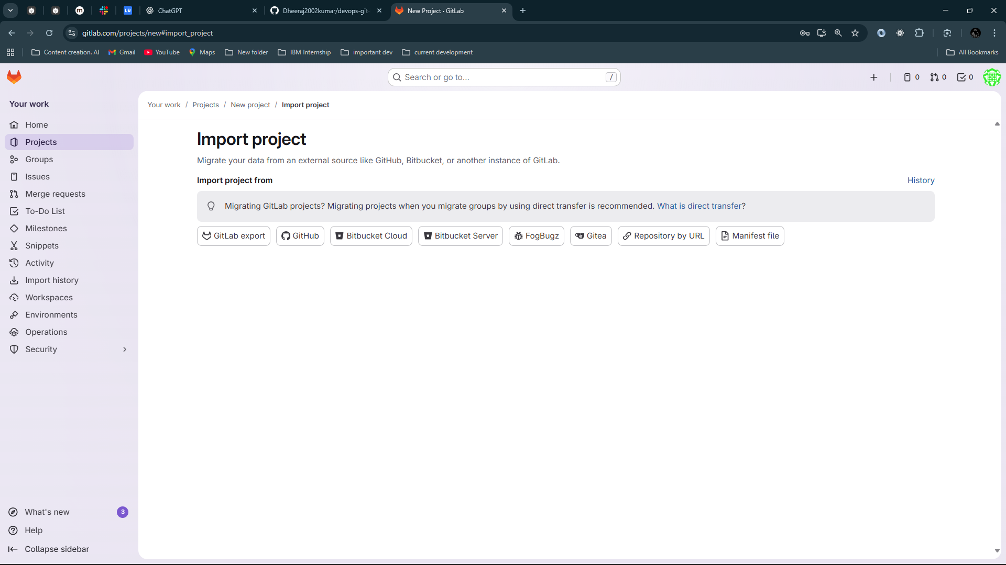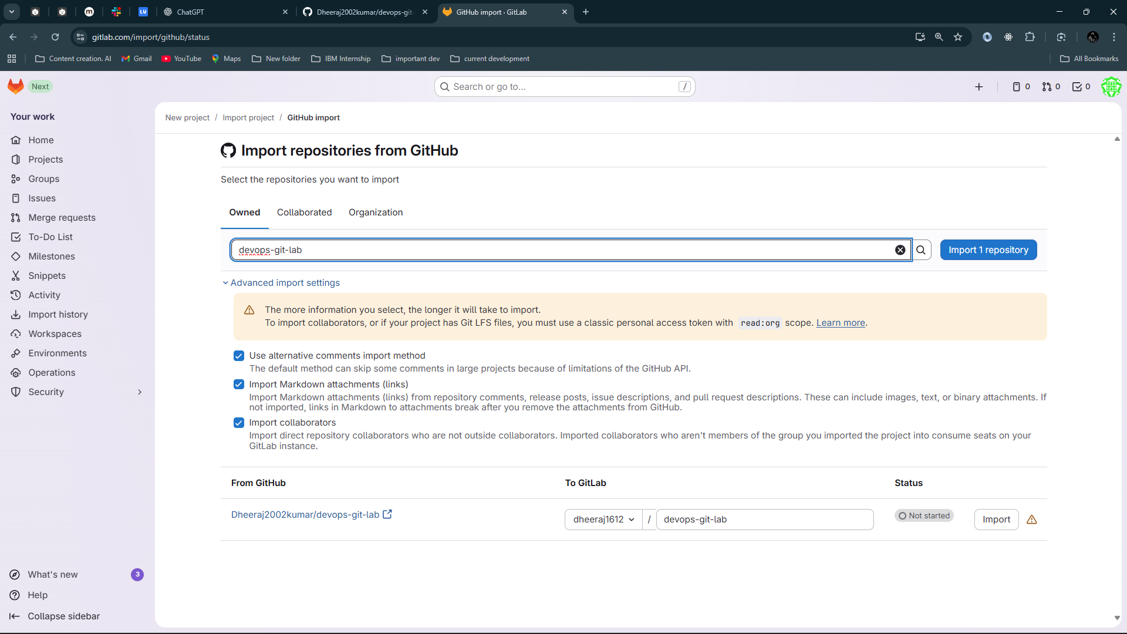

Write repository name and import it

# 

# ****GitLab Collaboration Workflow****

### A teammate clones from GitLab:

git clone <https://gitlab.com/dheeraj1612/devops-git-lab.git>

cd devops-git-lab

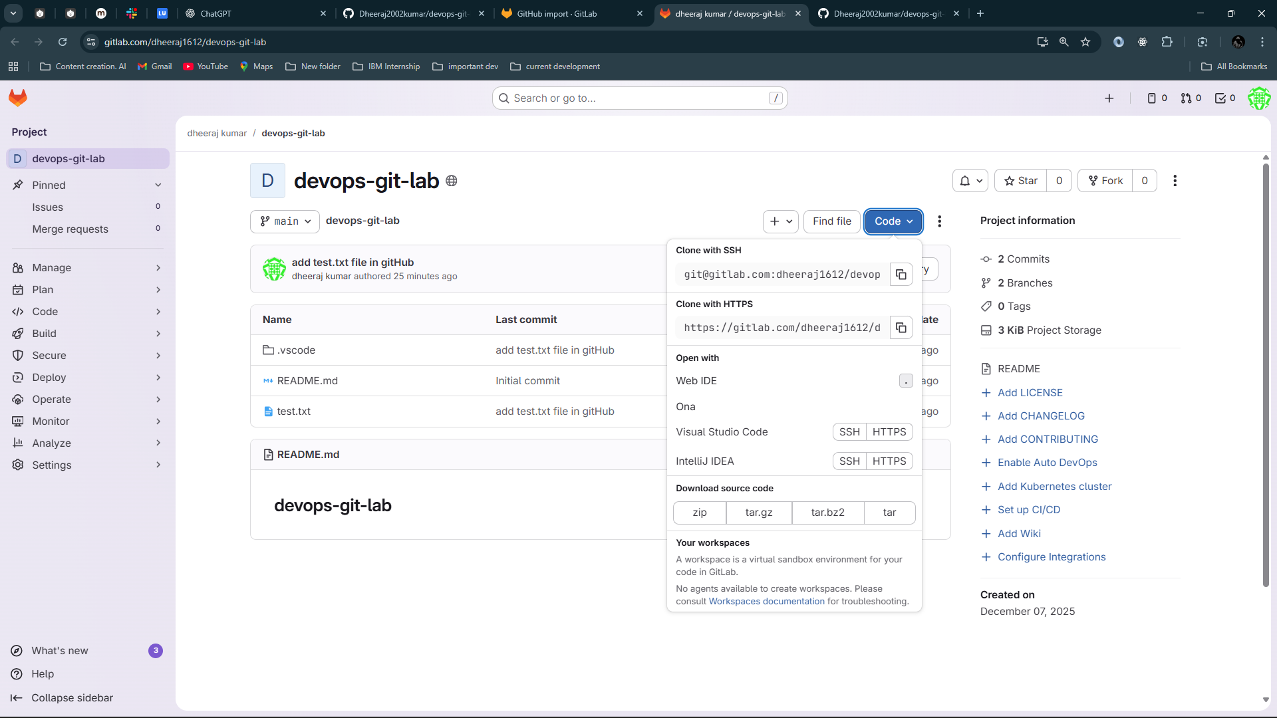

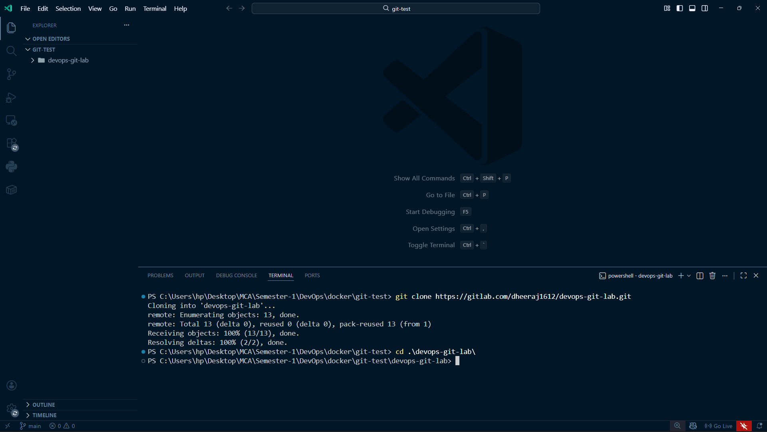

### Create a new branch:

git checkout -b feature-v3

echo "Version 3 changes" >> test.txt

git add test.txt

git commit -m "Added version 3 changes"

git push --set-upstream origin feature-v3

### On GitLab:

* Create **Merge Request**
* Run CI/CD pipeline (optional)
* Review & merge

### Sync changes back to GitHub (if mirroring enabled)

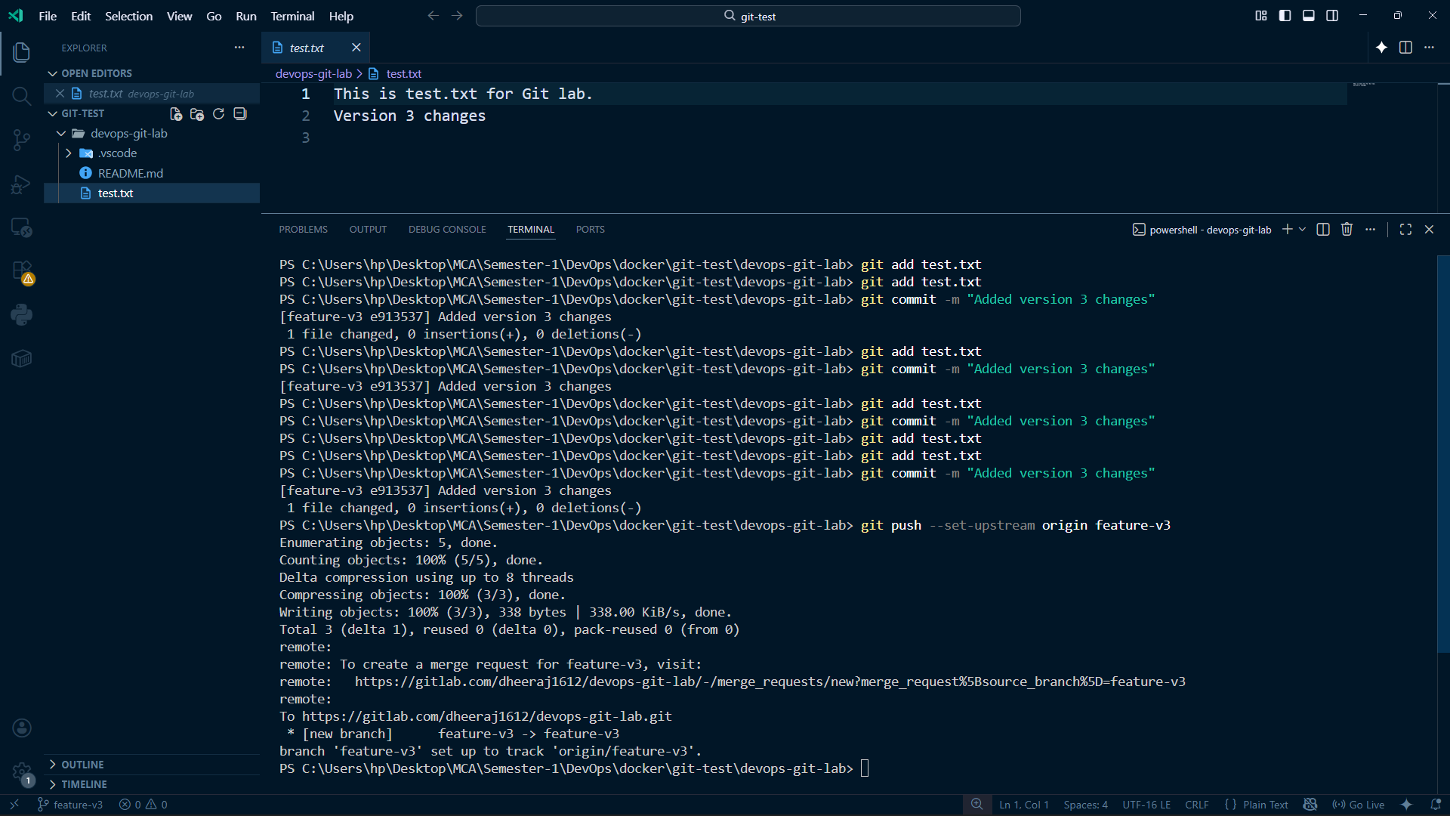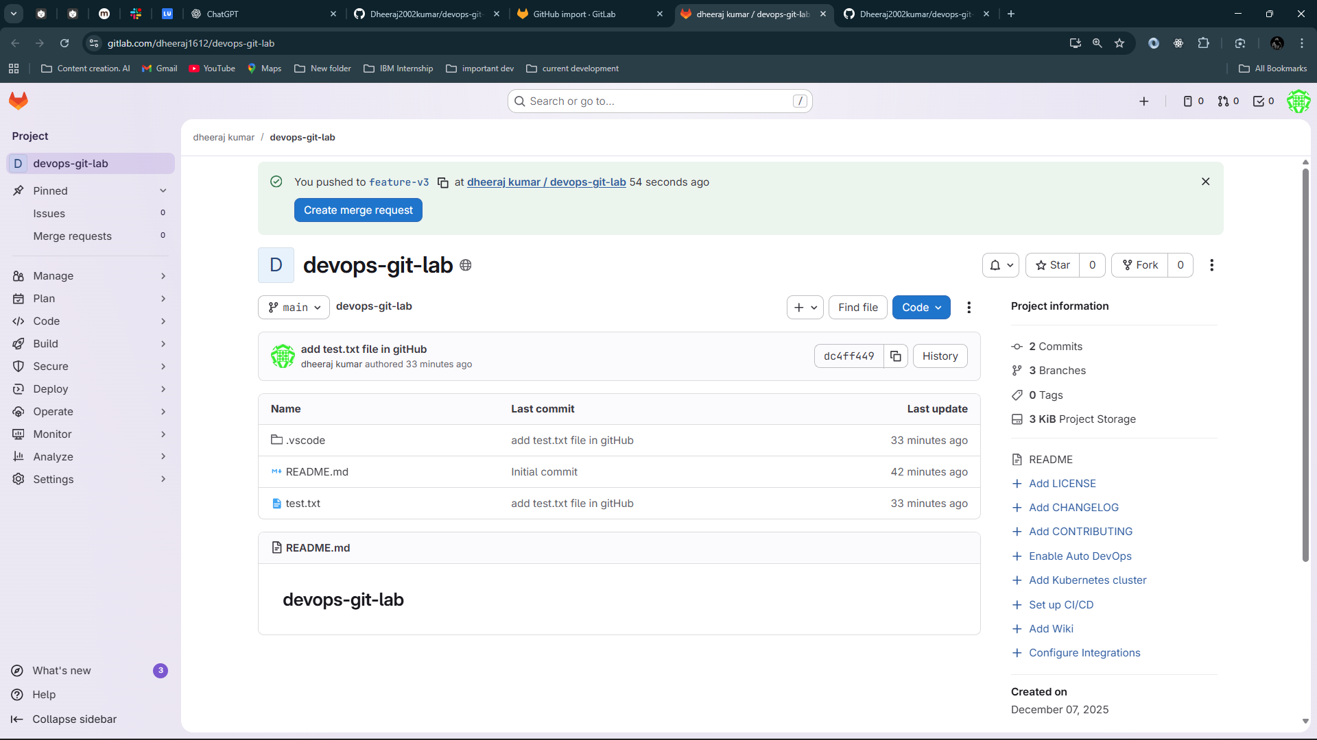

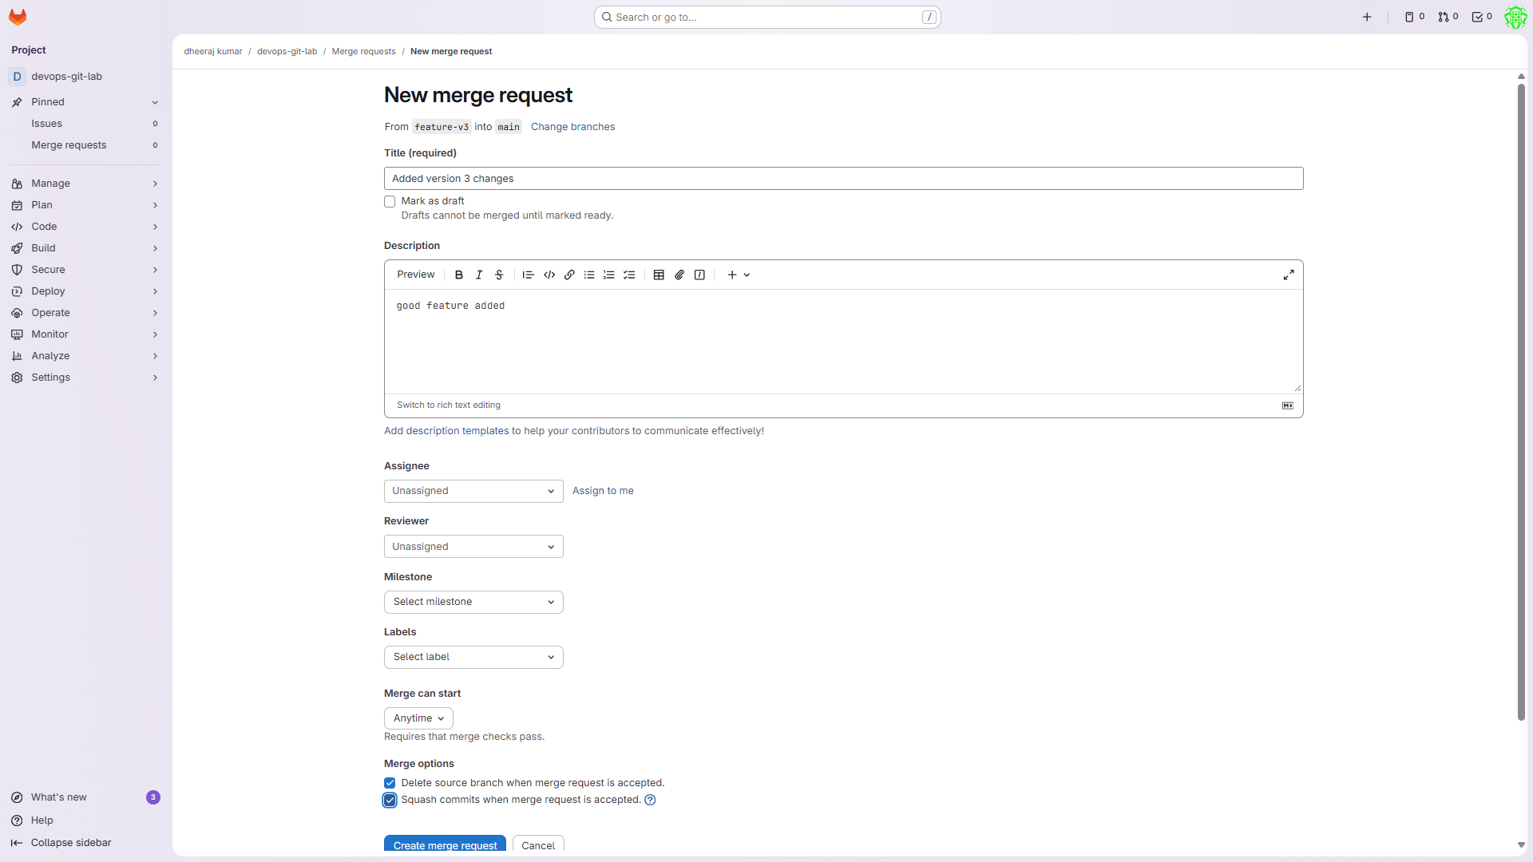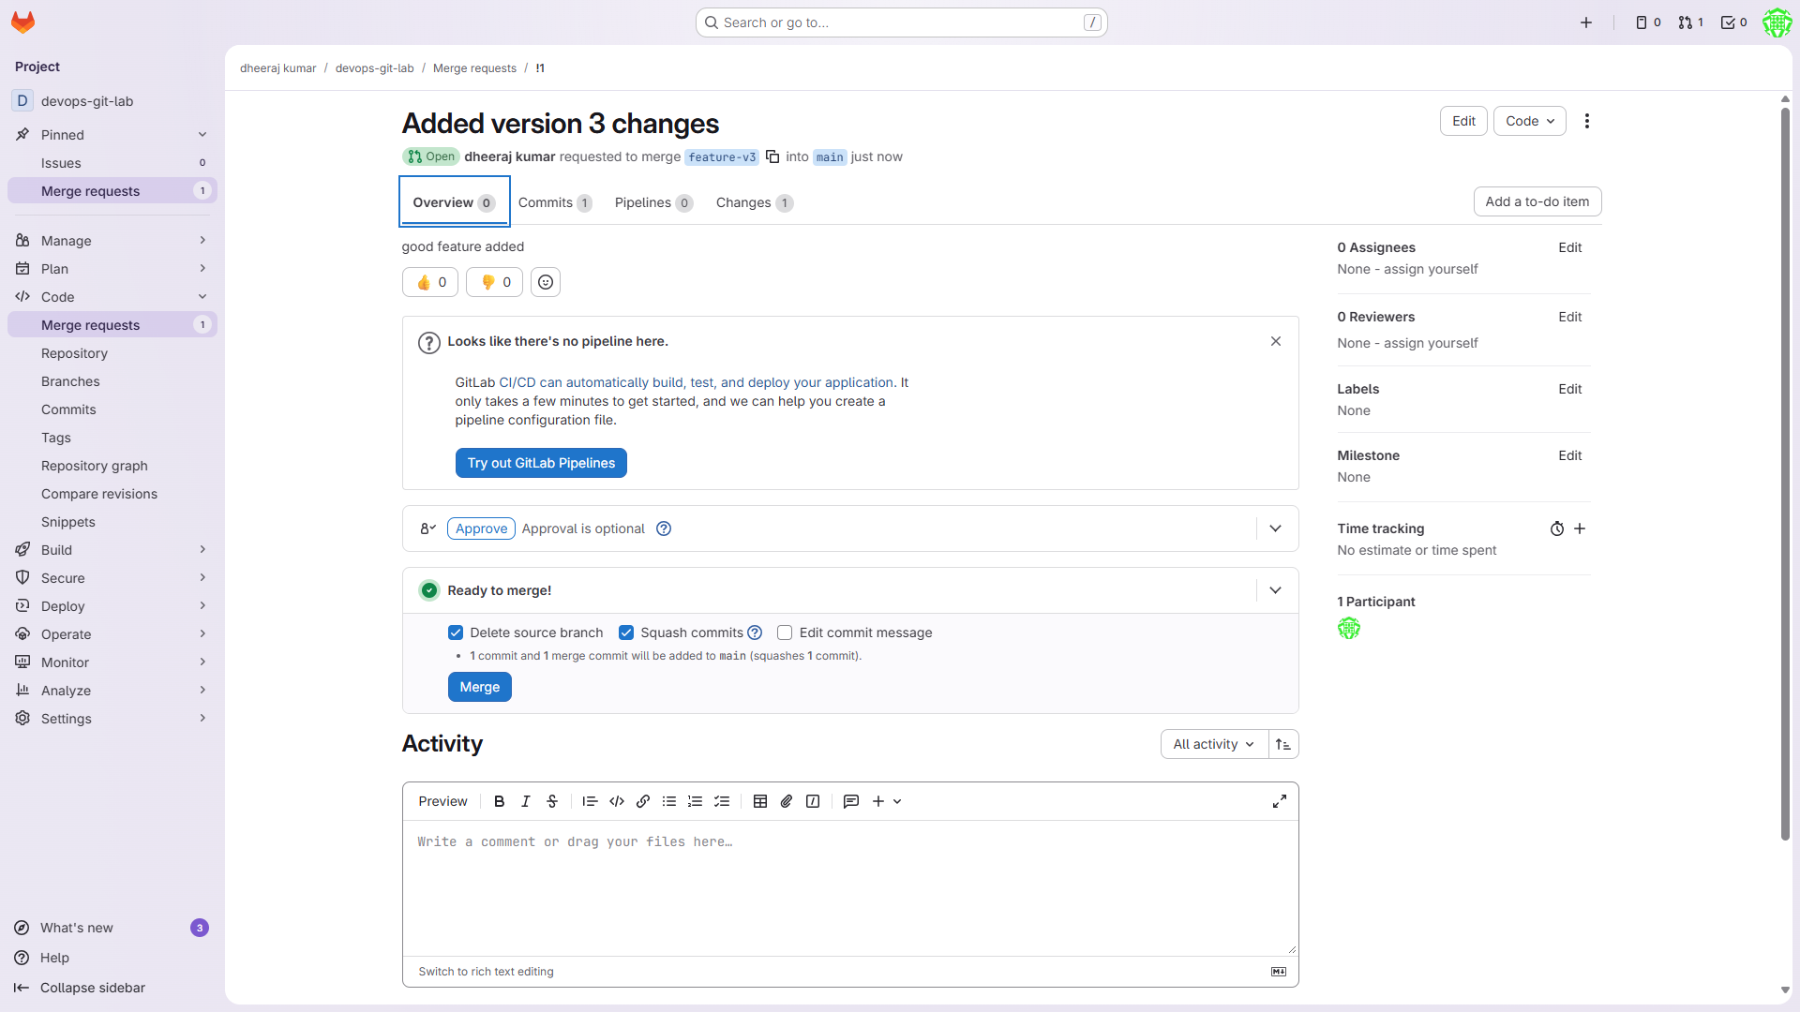

Click on merge

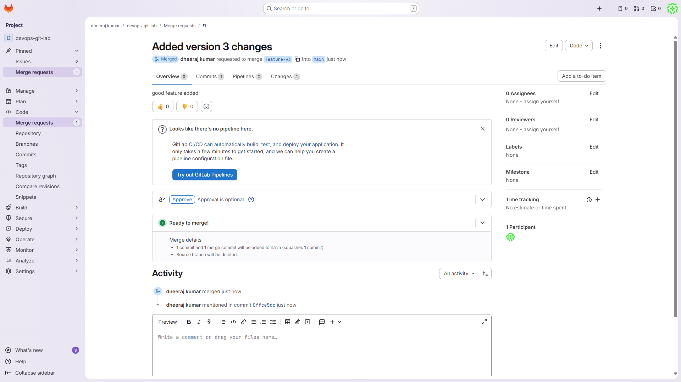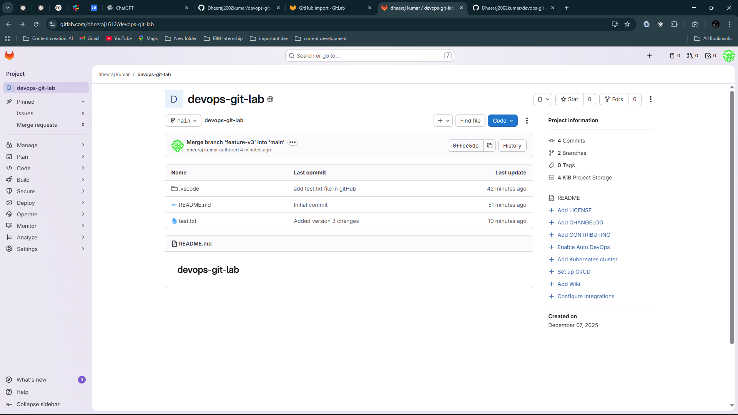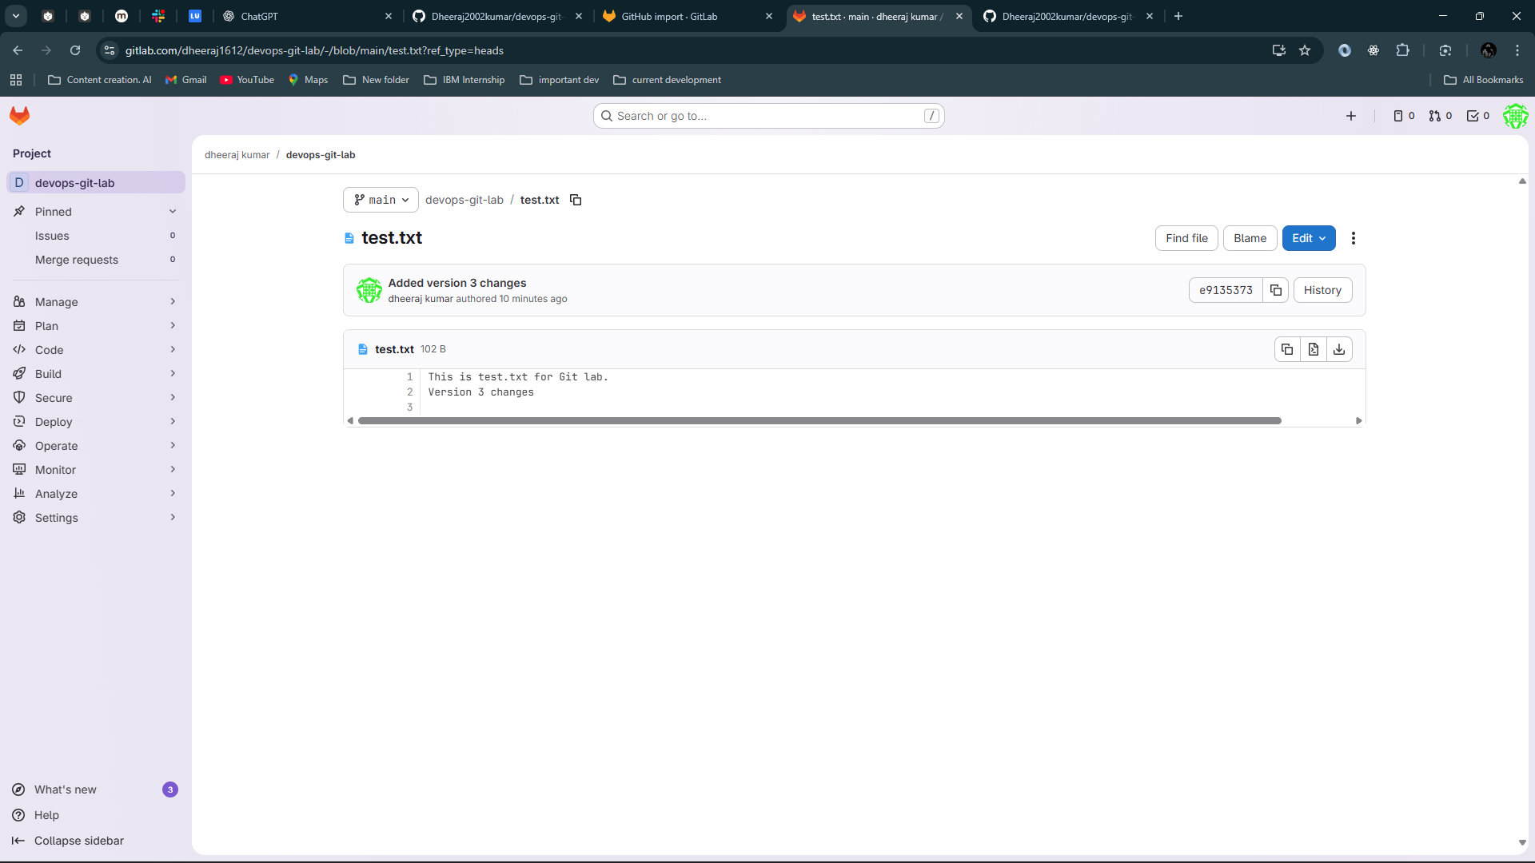

# ****Checking Git History & Version Control****

Show commit log:

git log --oneline --graph --all

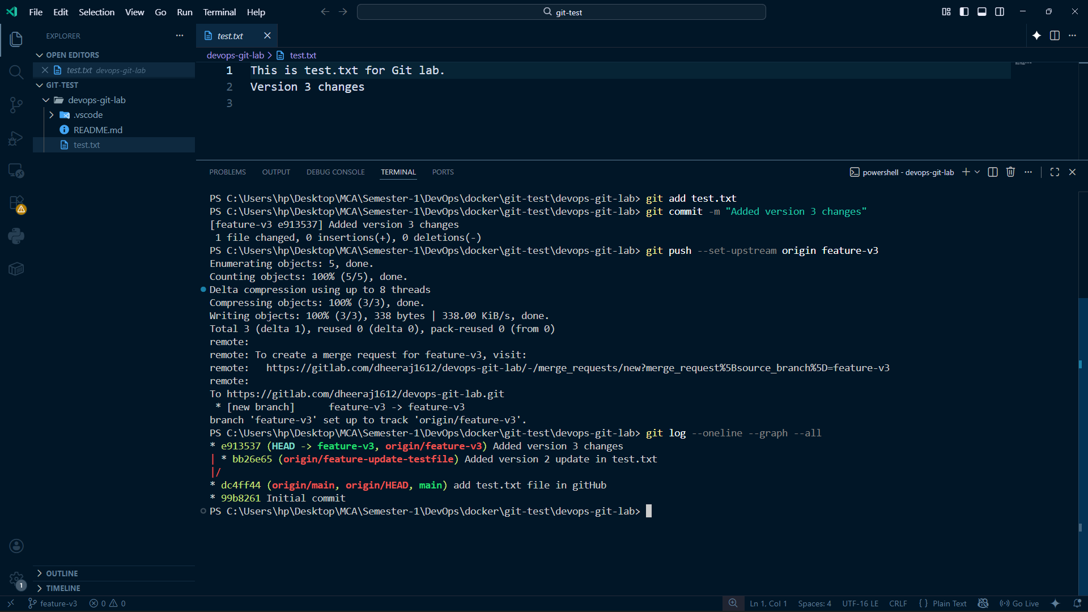

You can also merge using github

**Practical 2**

Lab on continuous Integration from different developers into a single piece of software using Jenkins.

**using Jenkins.**

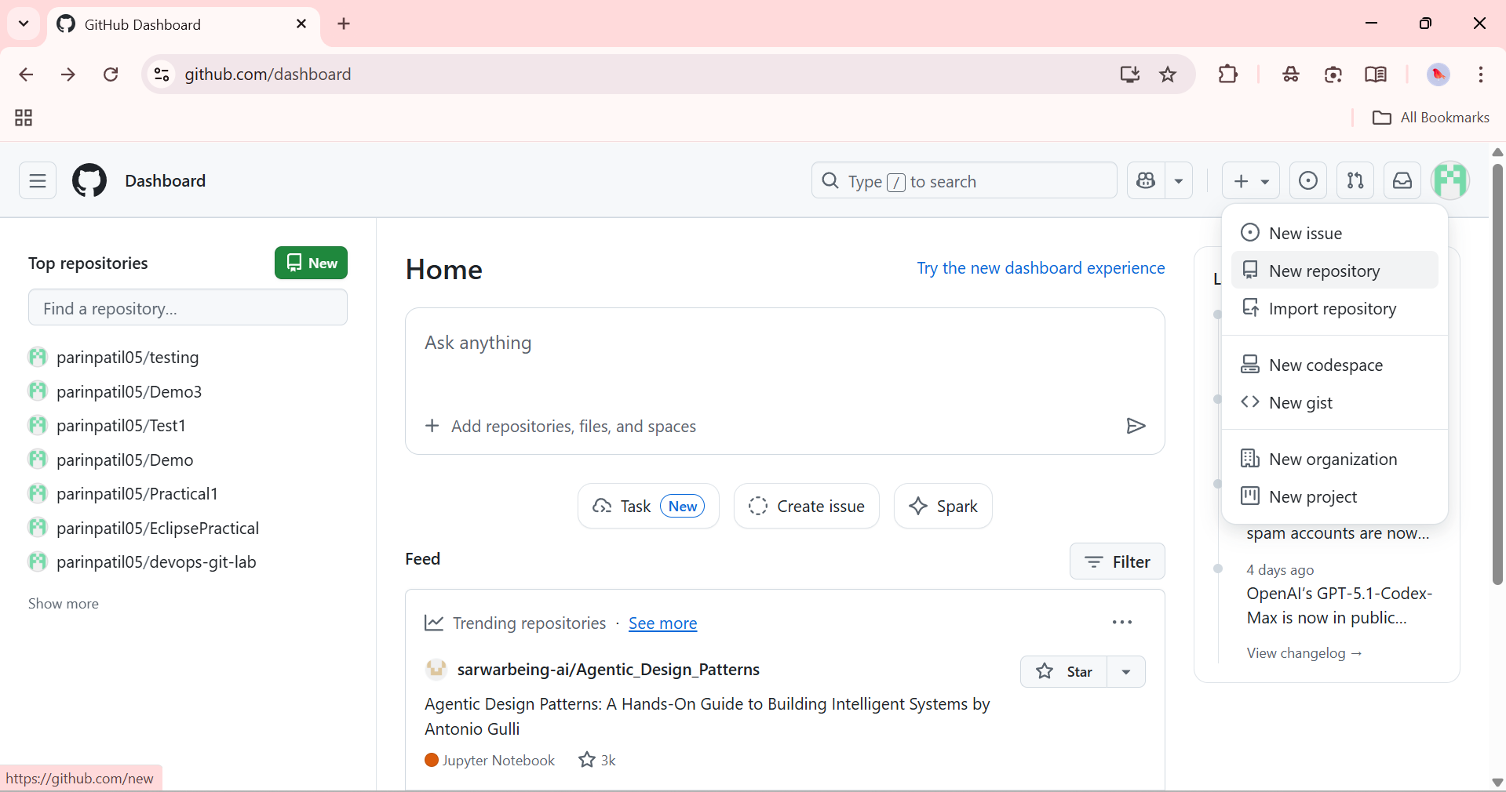

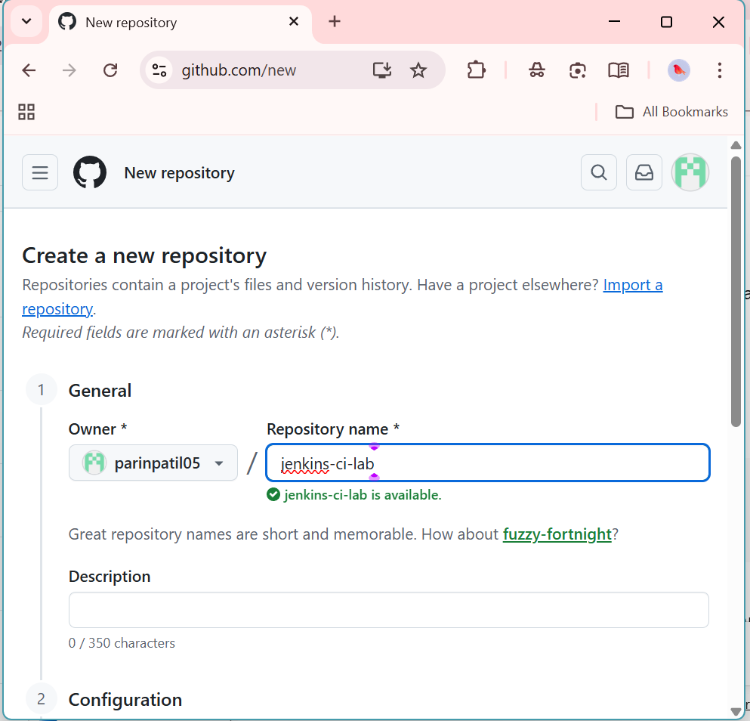

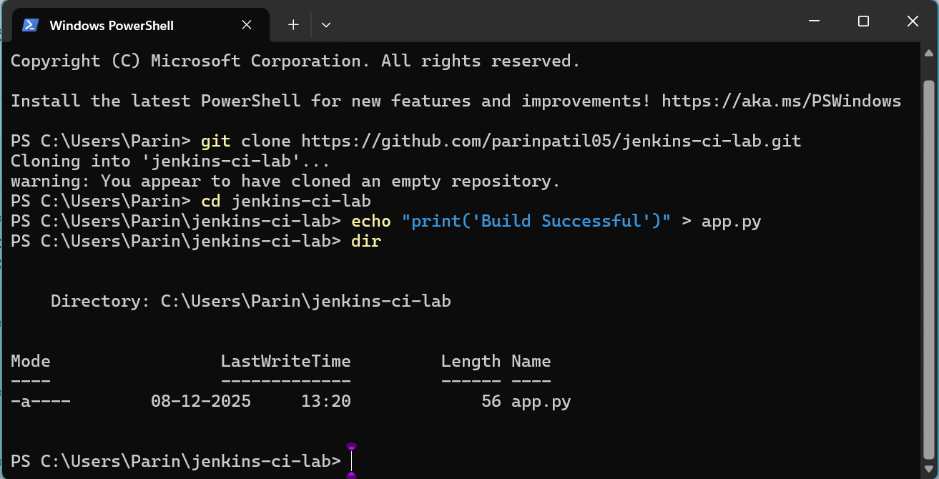

Run this command in terminal / PowerShell:

docker run -d -p 9090:8080 -p 50000:50000 --name jenkins jenkins/jenkins:lts

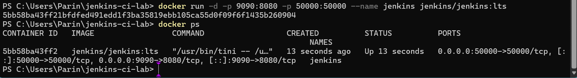

Open browser:

http://localhost:8080

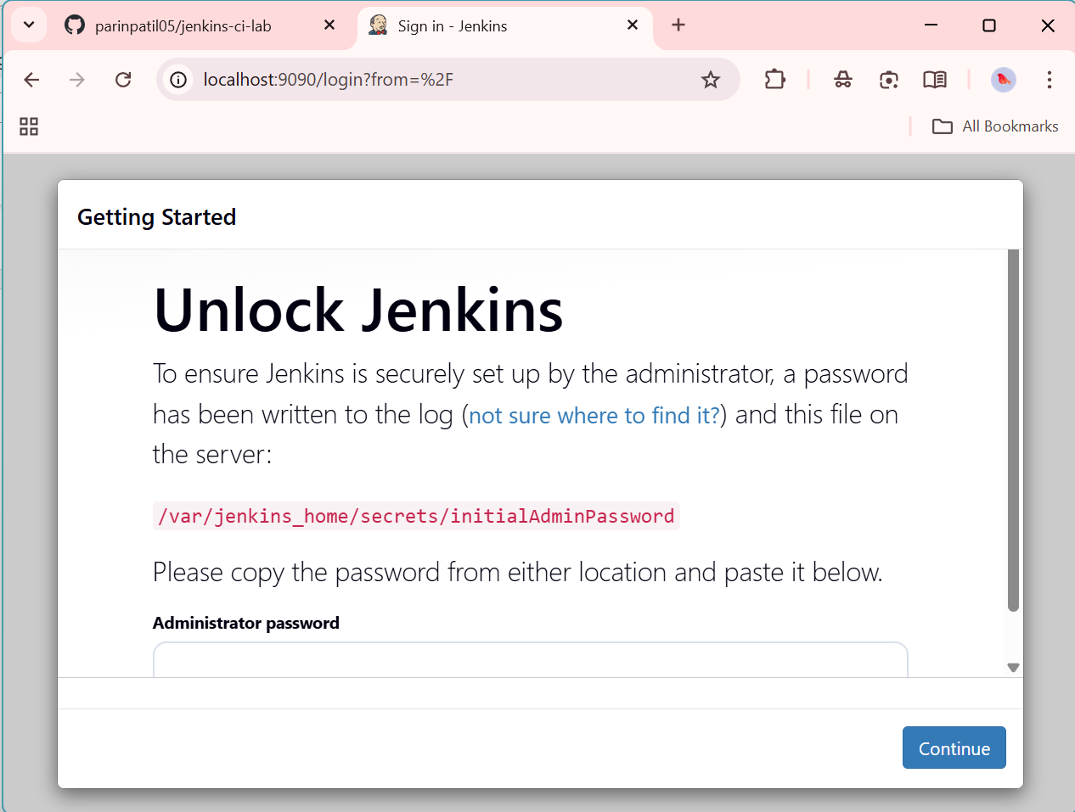

To get the admin password:

docker exec jenkins cat /var/jenkins_home/secrets/initialAdminPassword

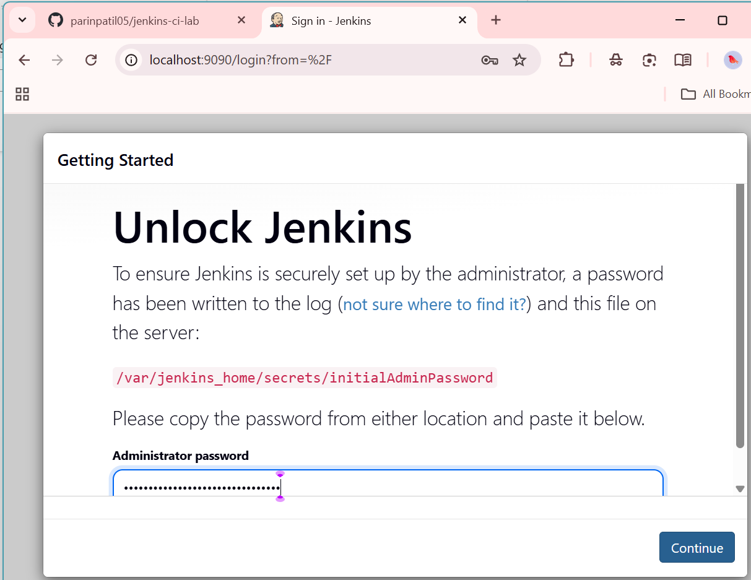

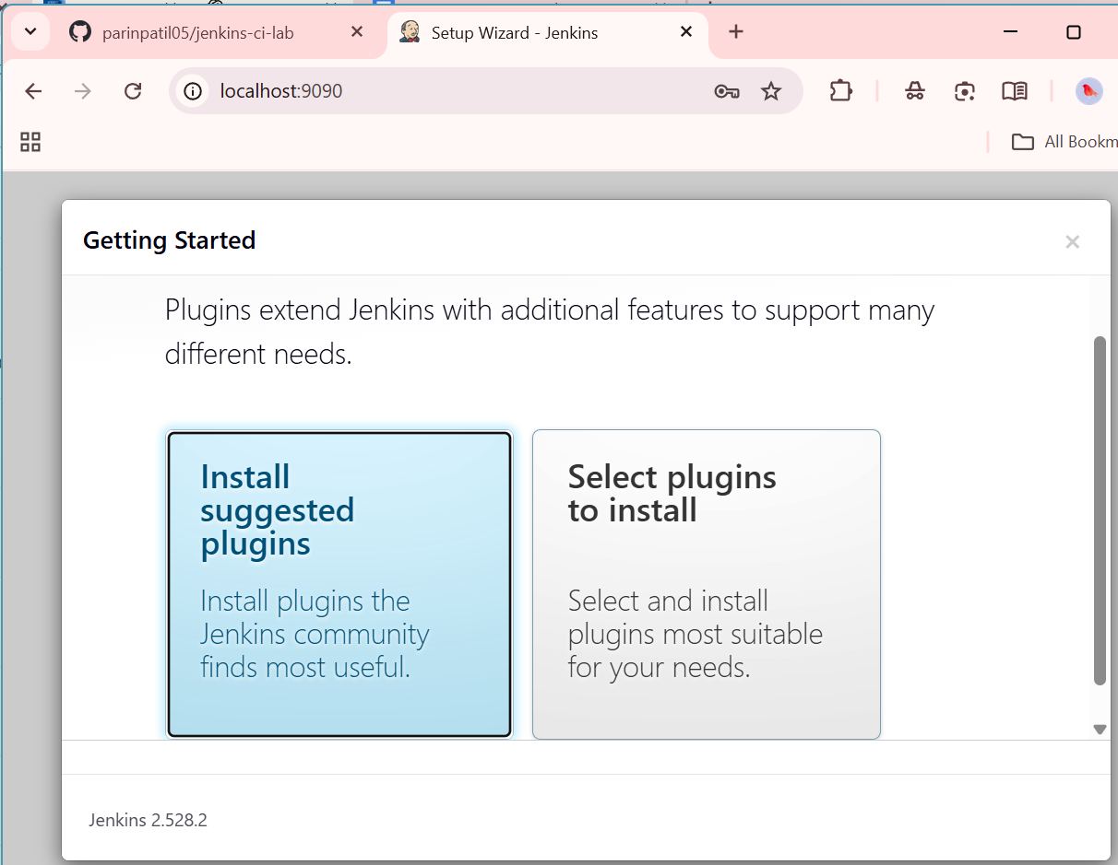

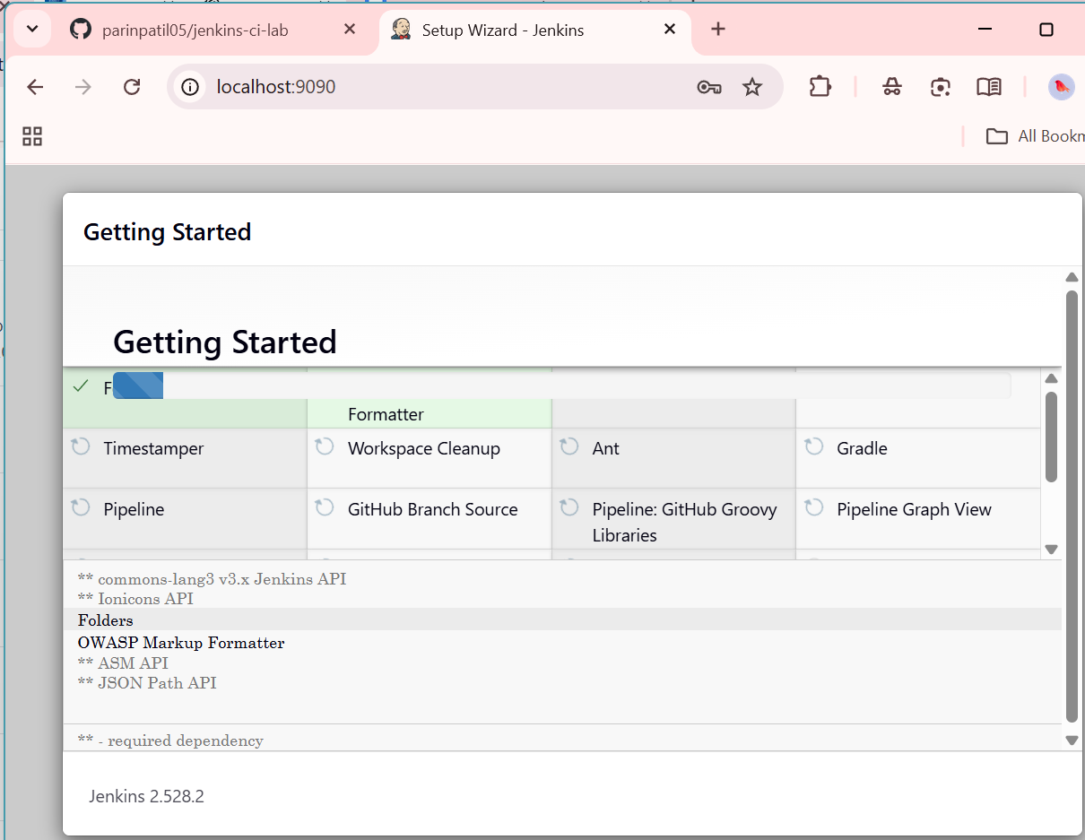

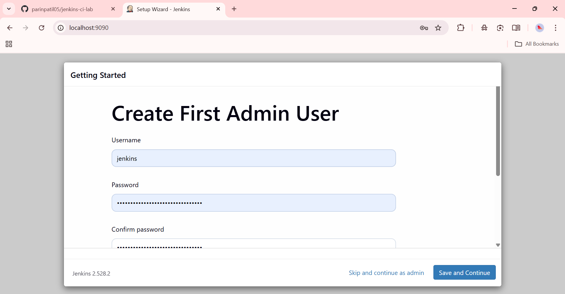

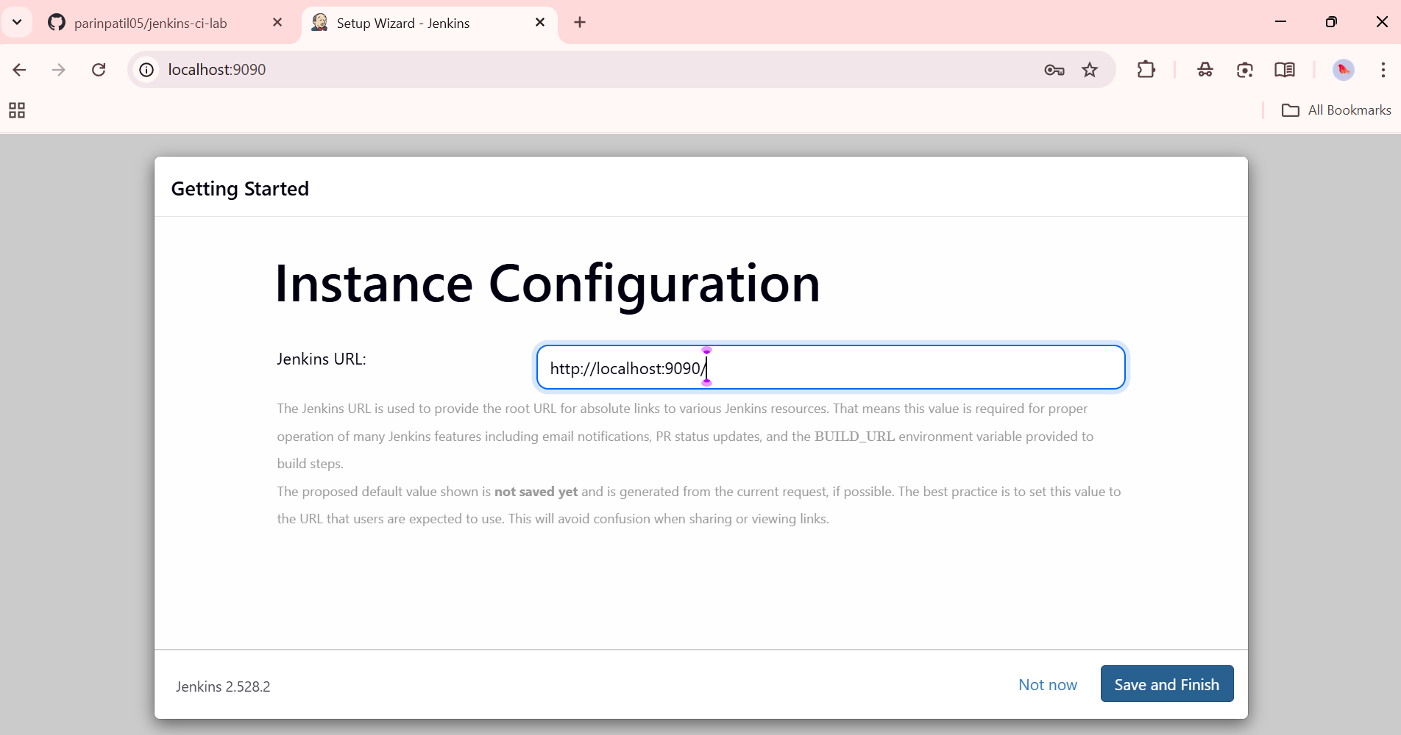

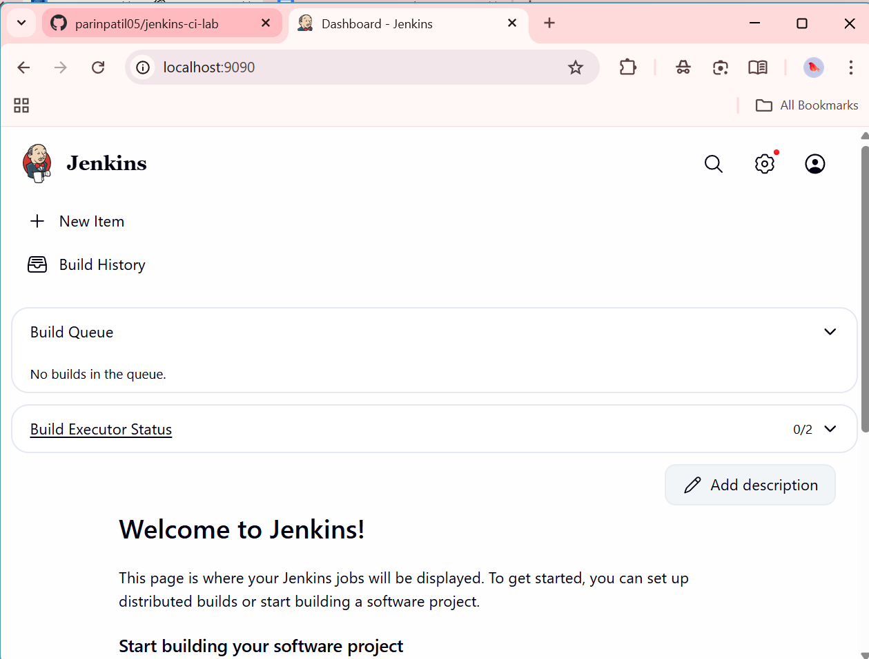

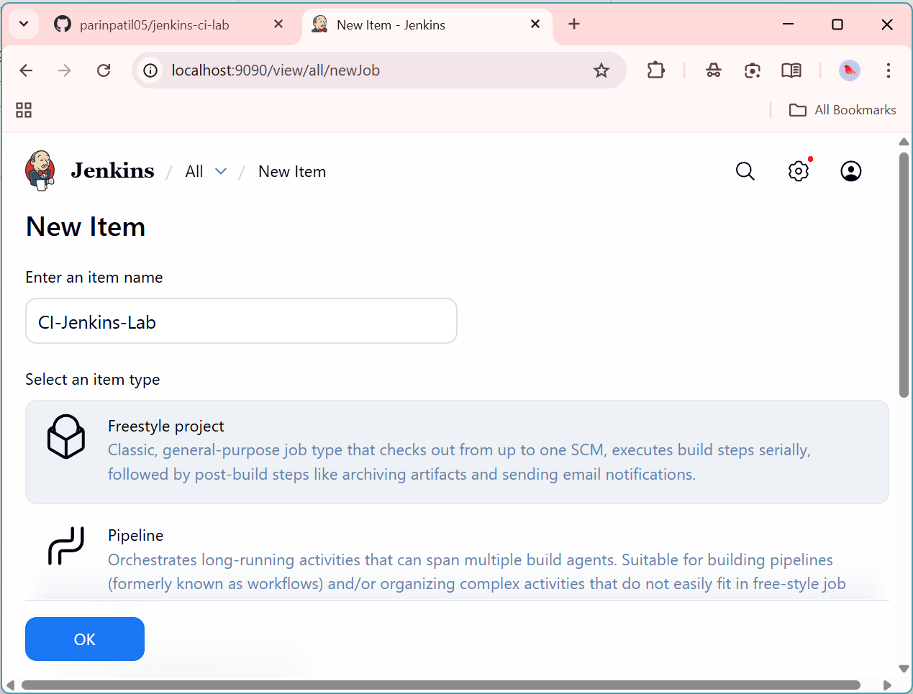

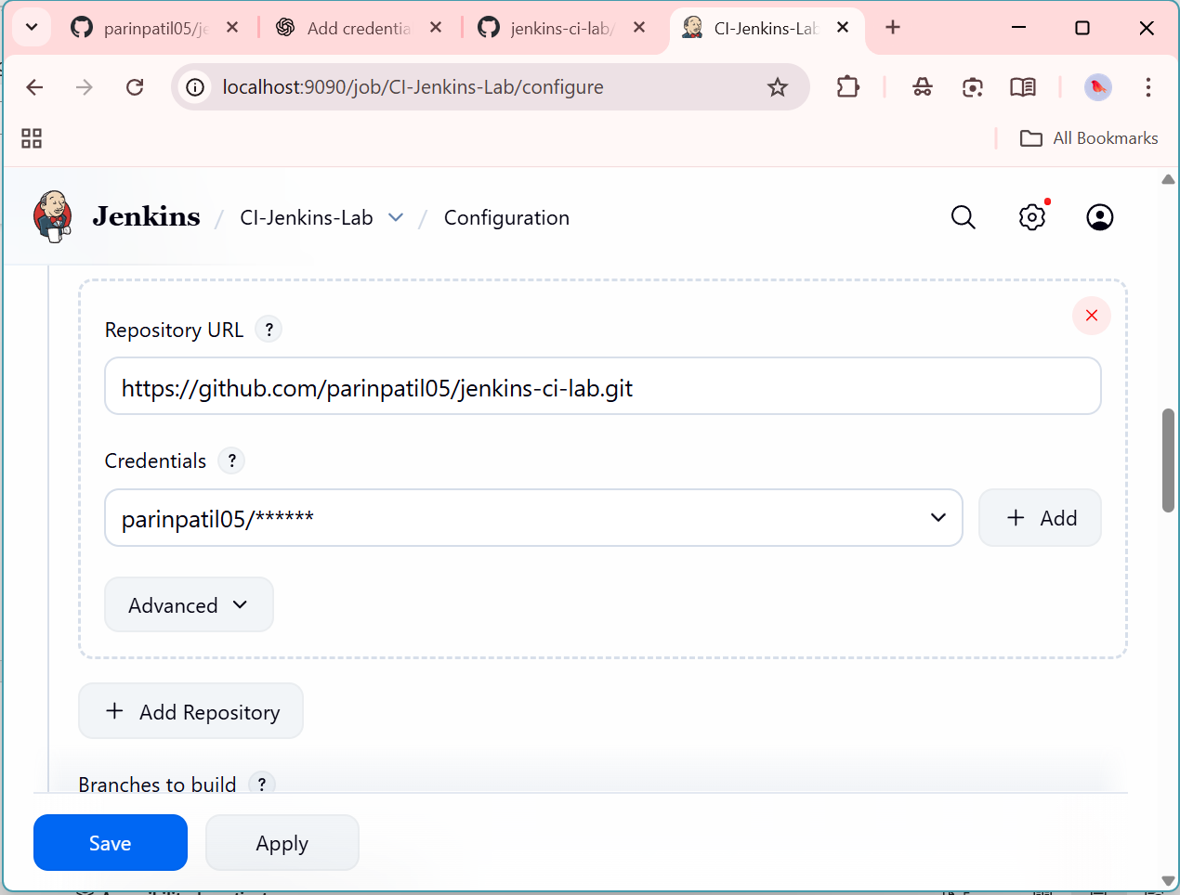

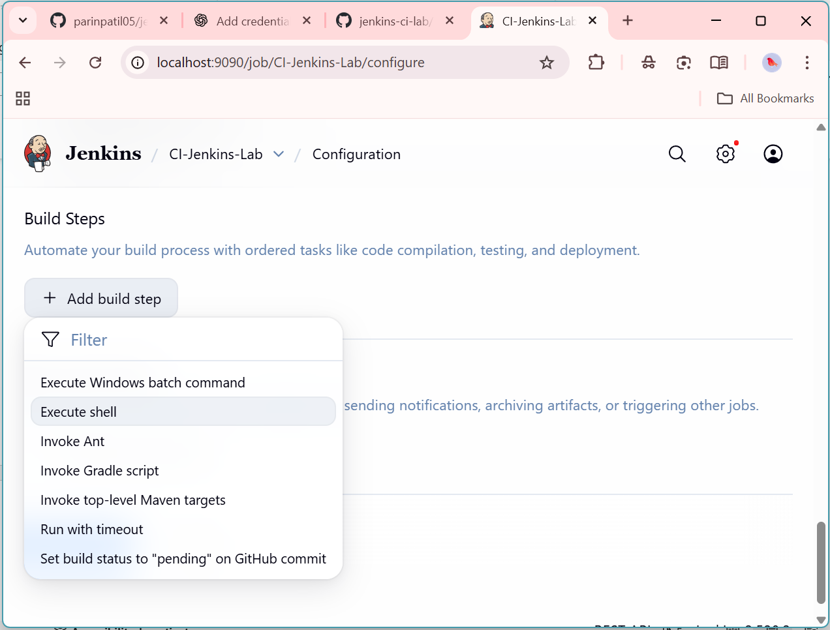

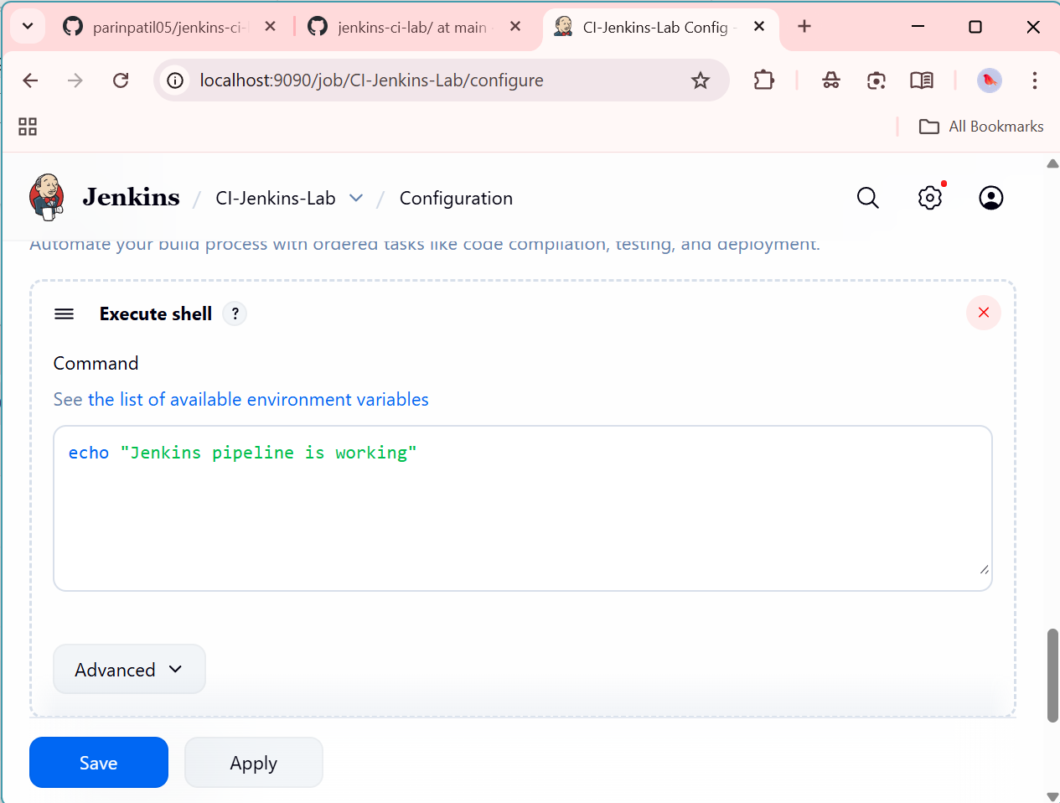

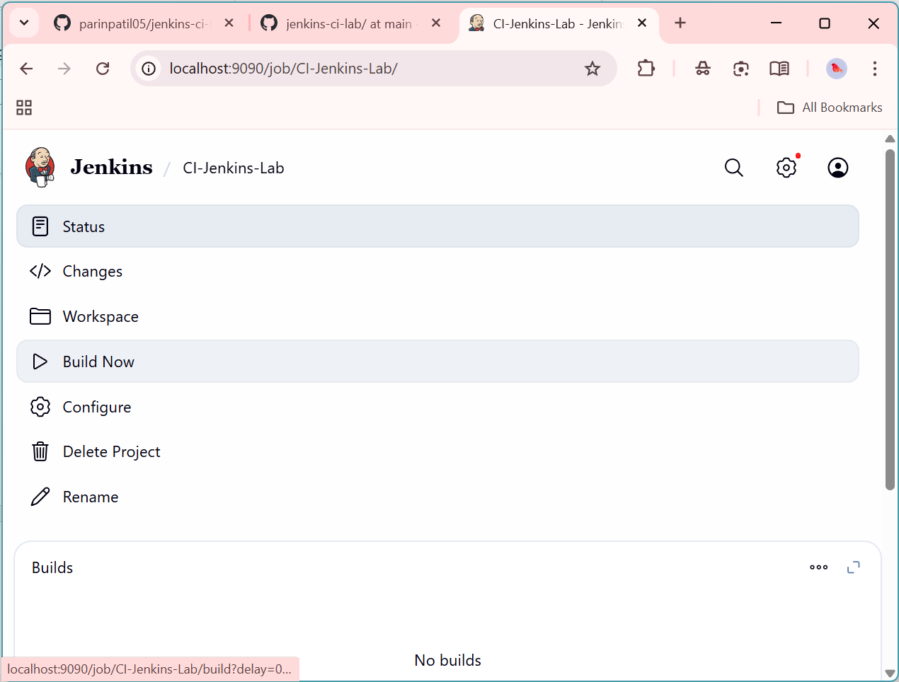

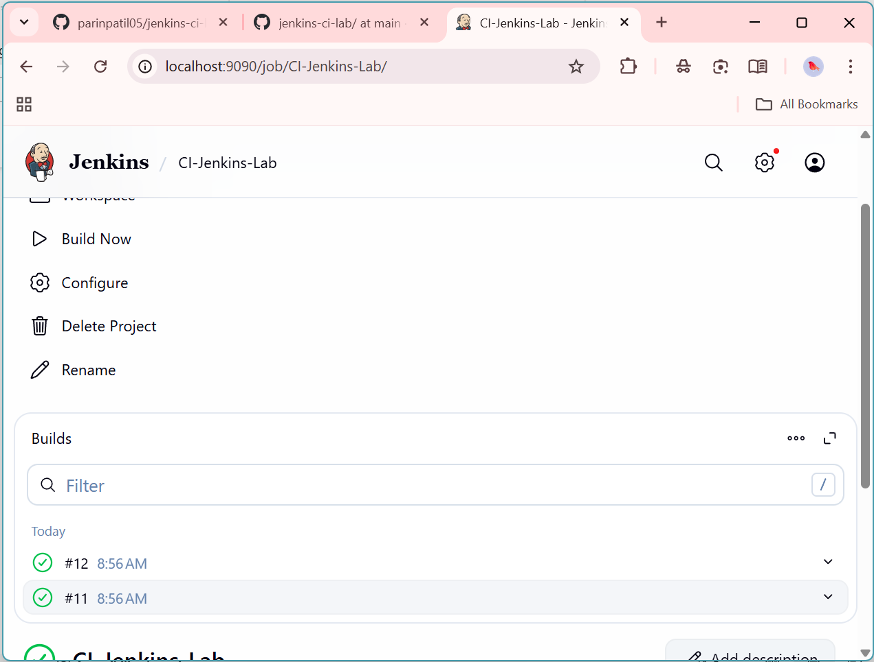

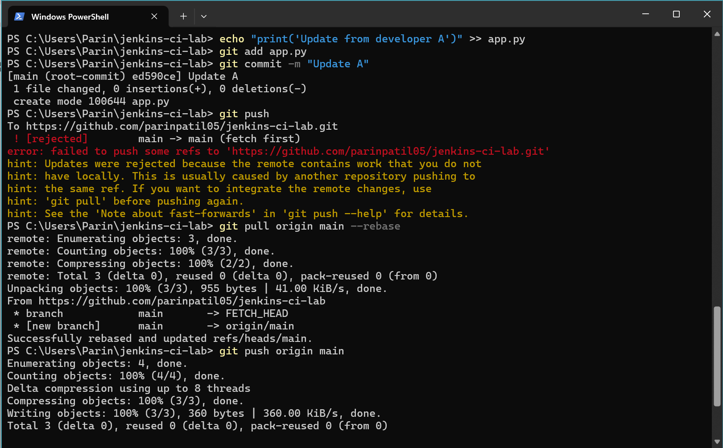



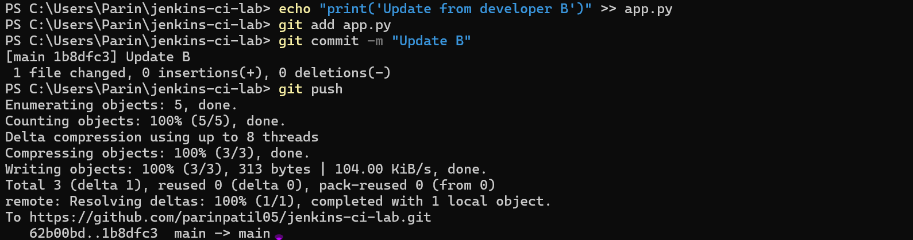

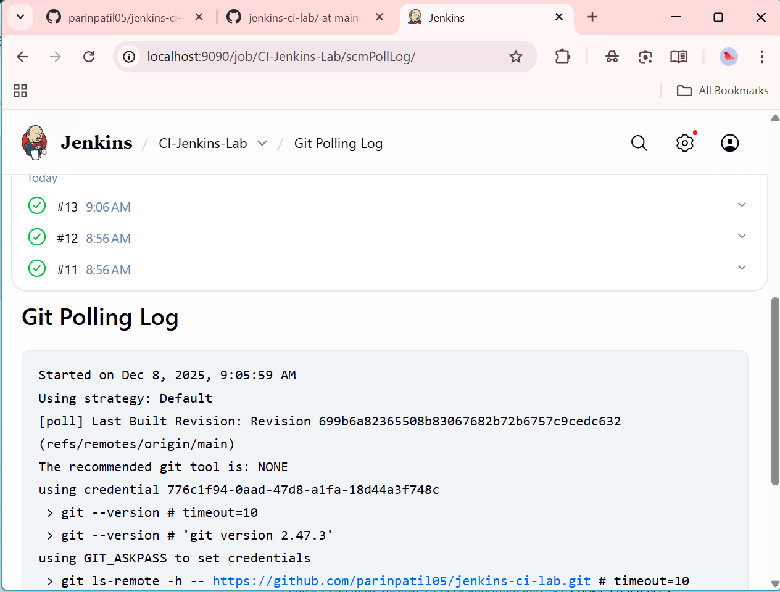

**Practical 3**

Testing the application using Selenium

from selenium import webdriver

from selenium.webdriver.chrome.service import Service

from selenium.webdriver.chrome.options import Options

from webdriver_manager.chrome import ChromeDriverManager

import time

chrome_path = "C:\\Program Files\\Google\\Chrome\\Application\\chrome.exe"

options = Options()

options.binary_location = chrome_path

print("Starting Chrome browser...")

driver = webdriver.Chrome(service=Service(ChromeDriverManager().install()), options=options)

driver.get("https://www.google.com")

print("Opened:", driver.title)

time.sleep(5)

driver.quit()

print("Program ended ✅")

**Run the code “python file_name.py”**

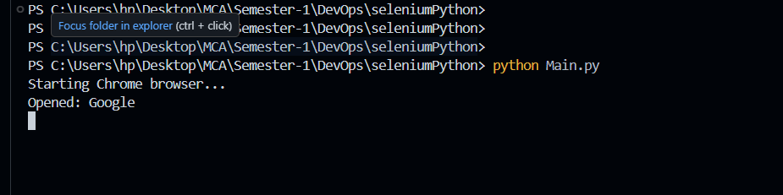

**Browser will open for 5 second and it will close after 5 second**

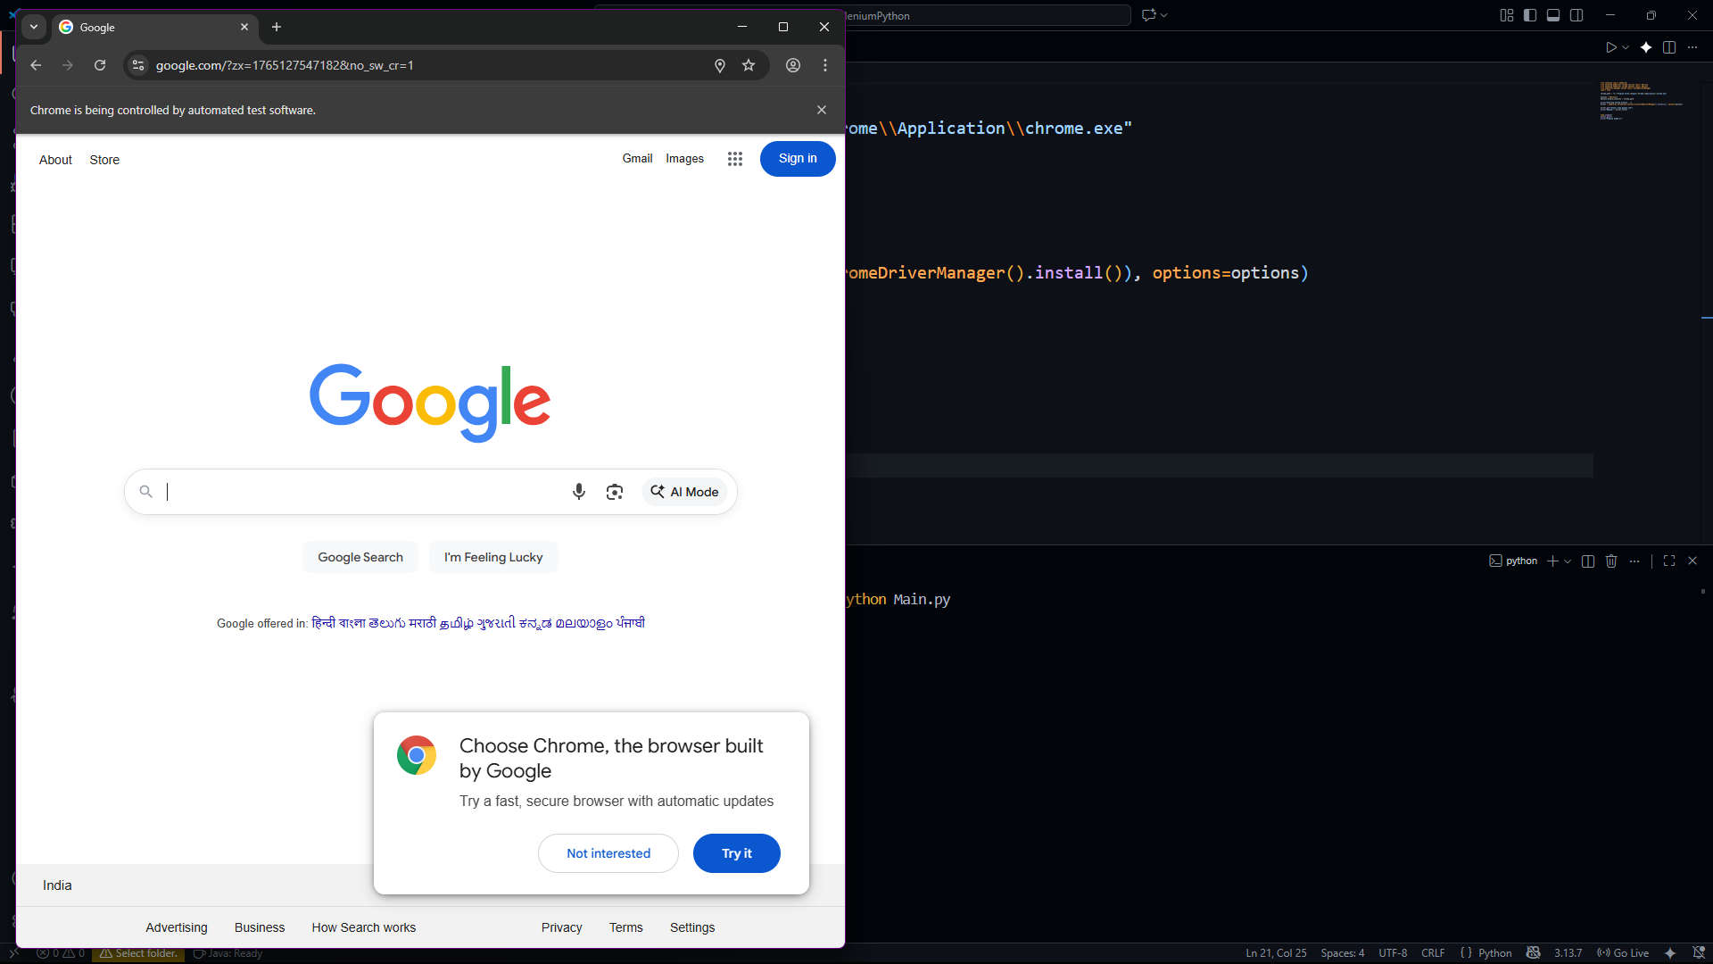

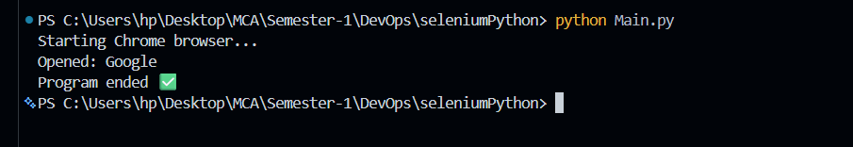

**Practical 4**

Testing the form using Selenium

from selenium import webdriver

from selenium.webdriver.support.ui import WebDriverWait

from selenium.webdriver.common.by import By

from selenium.webdriver.support.ui import WebDriverWait

from selenium.webdriver.support import expected_conditions as EC

from selenium.webdriver.chrome.service import Service

from webdriver_manager.chrome import ChromeDriverManager

import time

# setp 1: launch browser

driver = webdriver.Chrome(service=Service(ChromeDriverManager().install()))

driver.get("https://www.w3schools.com/html/html_forms.asp")

driver.maximize_window()

time.sleep(2)

# step 2: scroll to the form

driver.execute_script("window.scrollTo(0, 800)")

time.sleep(1)

# step 3: fill out the example form

fname = driver.find_element(By.ID, "fname")

lname = driver.find_element(By.ID, "lname")

fname.clear()

lname.clear()

fname.send_keys("Dheeraj")

lname.send_keys("Kumar")

# step 4: submit the form (it opens in new tab)

submit_btn = driver.find_element(By.XPATH, "//input[@type='submit']")

submit_btn.click()

print("✅ Form filled and submitted successfully!")

time.sleep(4)

driver.quit()

**Run the code “python file_name.py”**

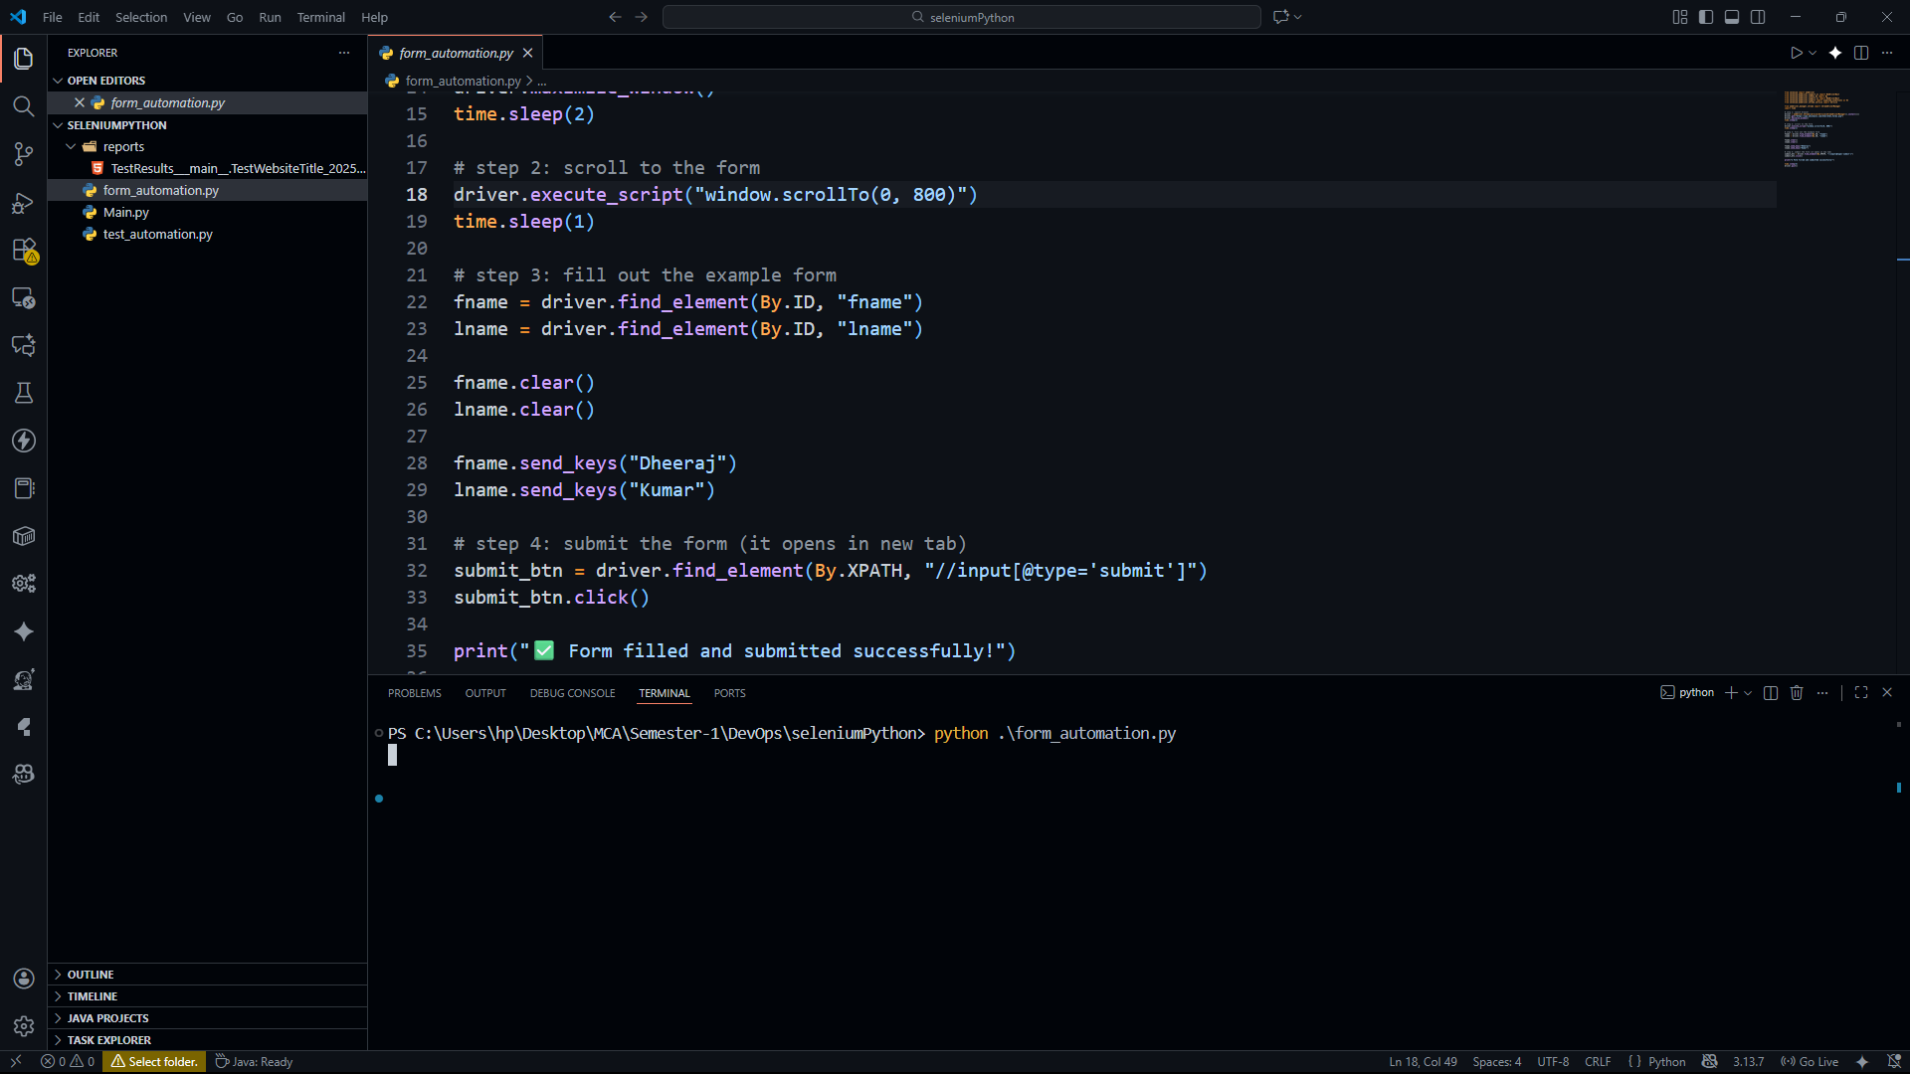

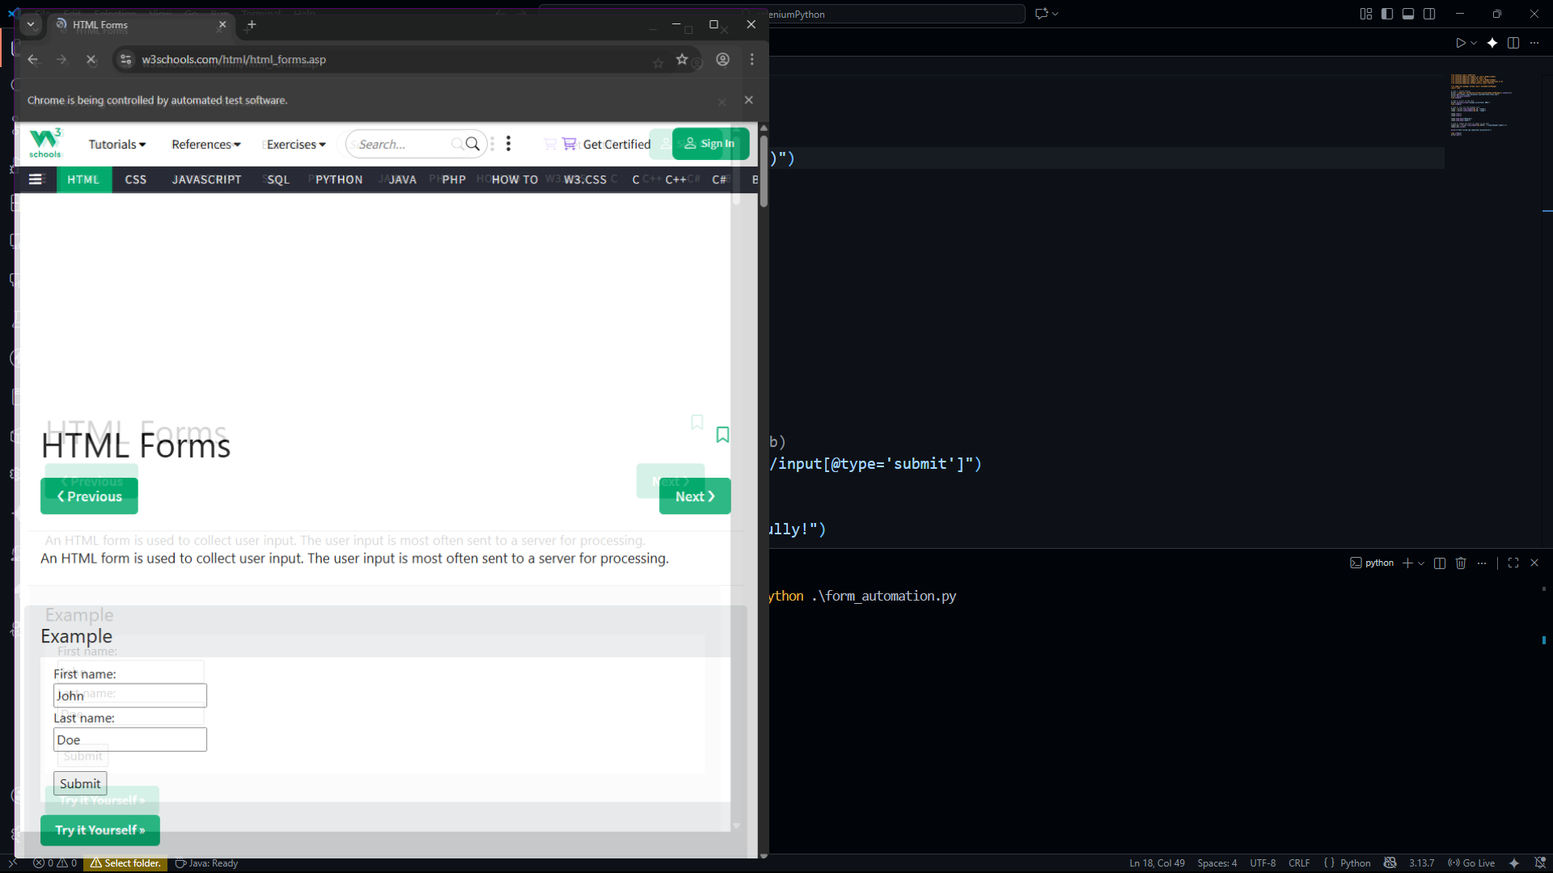

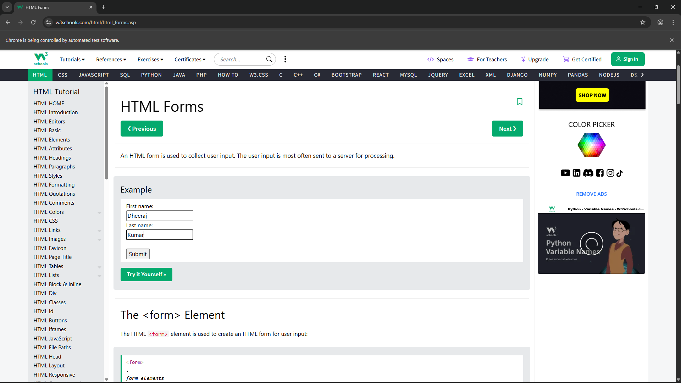

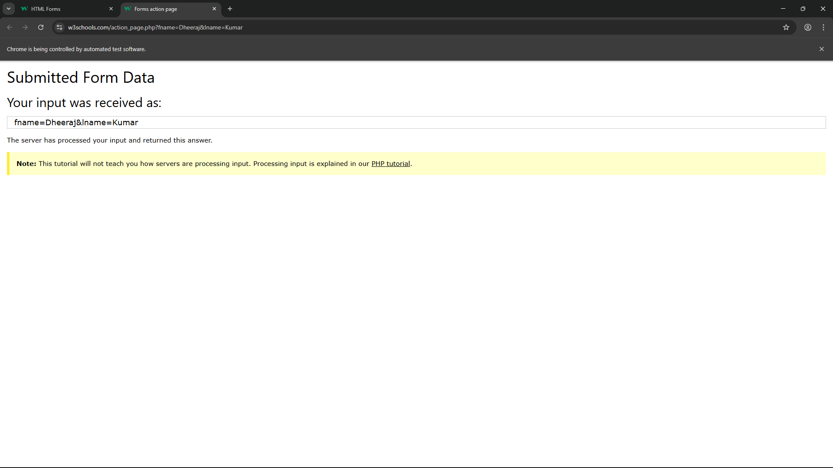

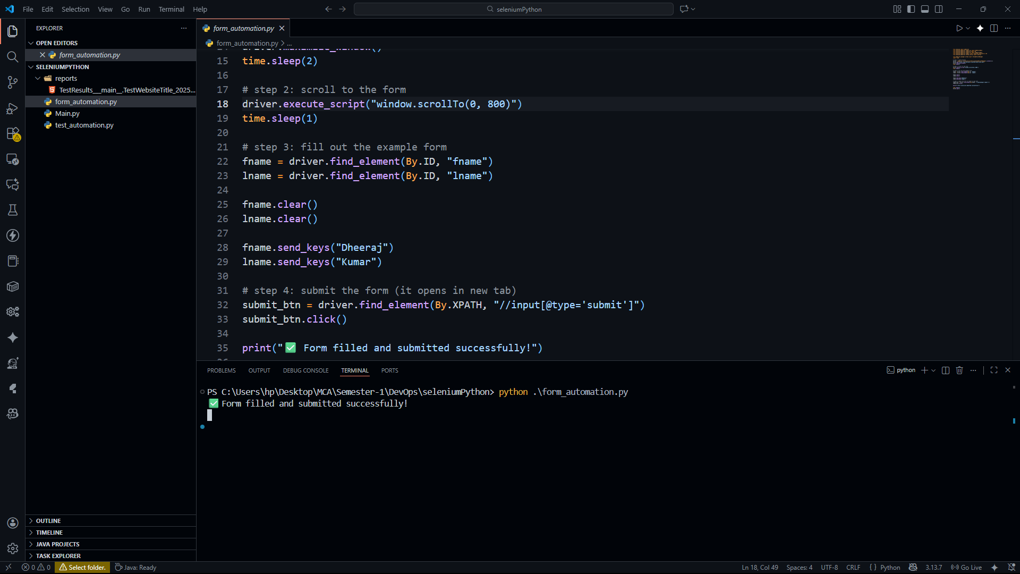

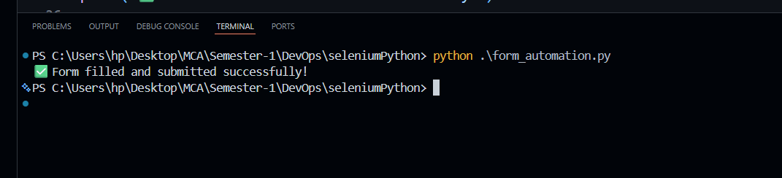

**Practical 5**

Testing automation and HTML report generation using selenium

import unittest

import time

import HtmlTestRunner

from selenium import webdriver

from selenium.webdriver.chrome.service import Service

from webdriver_manager.chrome import ChromeDriverManager

class TestWebsiteTitle(unittest.TestCase):

    def setUp(self):

        """Setup browser before each test"""

        self.driver = webdriver.Chrome(service=Service(ChromeDriverManager().install()))

        self.driver.maximize_window()

        self.driver.get("https://concertcraze.netlify.app/")

        time.sleep(2)

    def test_title_verification(self):

        """Check if website title is correct"""

        driver = self.driver

        expected_title = "Landing Page"  # correct title

        actual_title = driver.title

        self.assertEqual(expected_title, actual_title)

        print(f"Test Passed: Title matches -> {actual_title}")

    def tearDown(self):

        """Close browser after test"""

        self.driver.quit()

if __name__ == "__main__":

    unittest.main(

        testRunner=HtmlTestRunner.HTMLTestRunner(

            output='reports'   # report folder will be created automatically

        )

    )

**Run the code “Python file_name.py”**

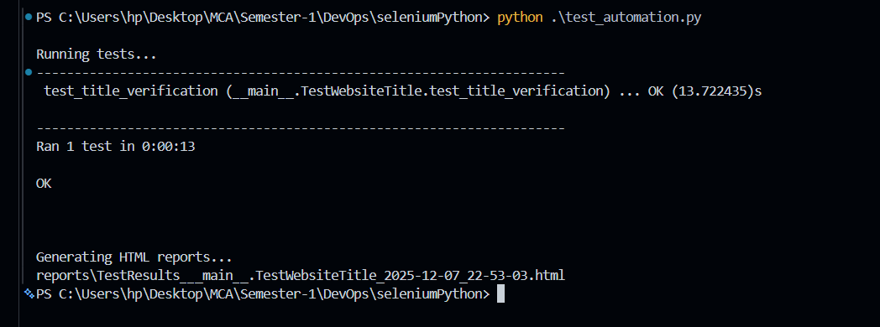

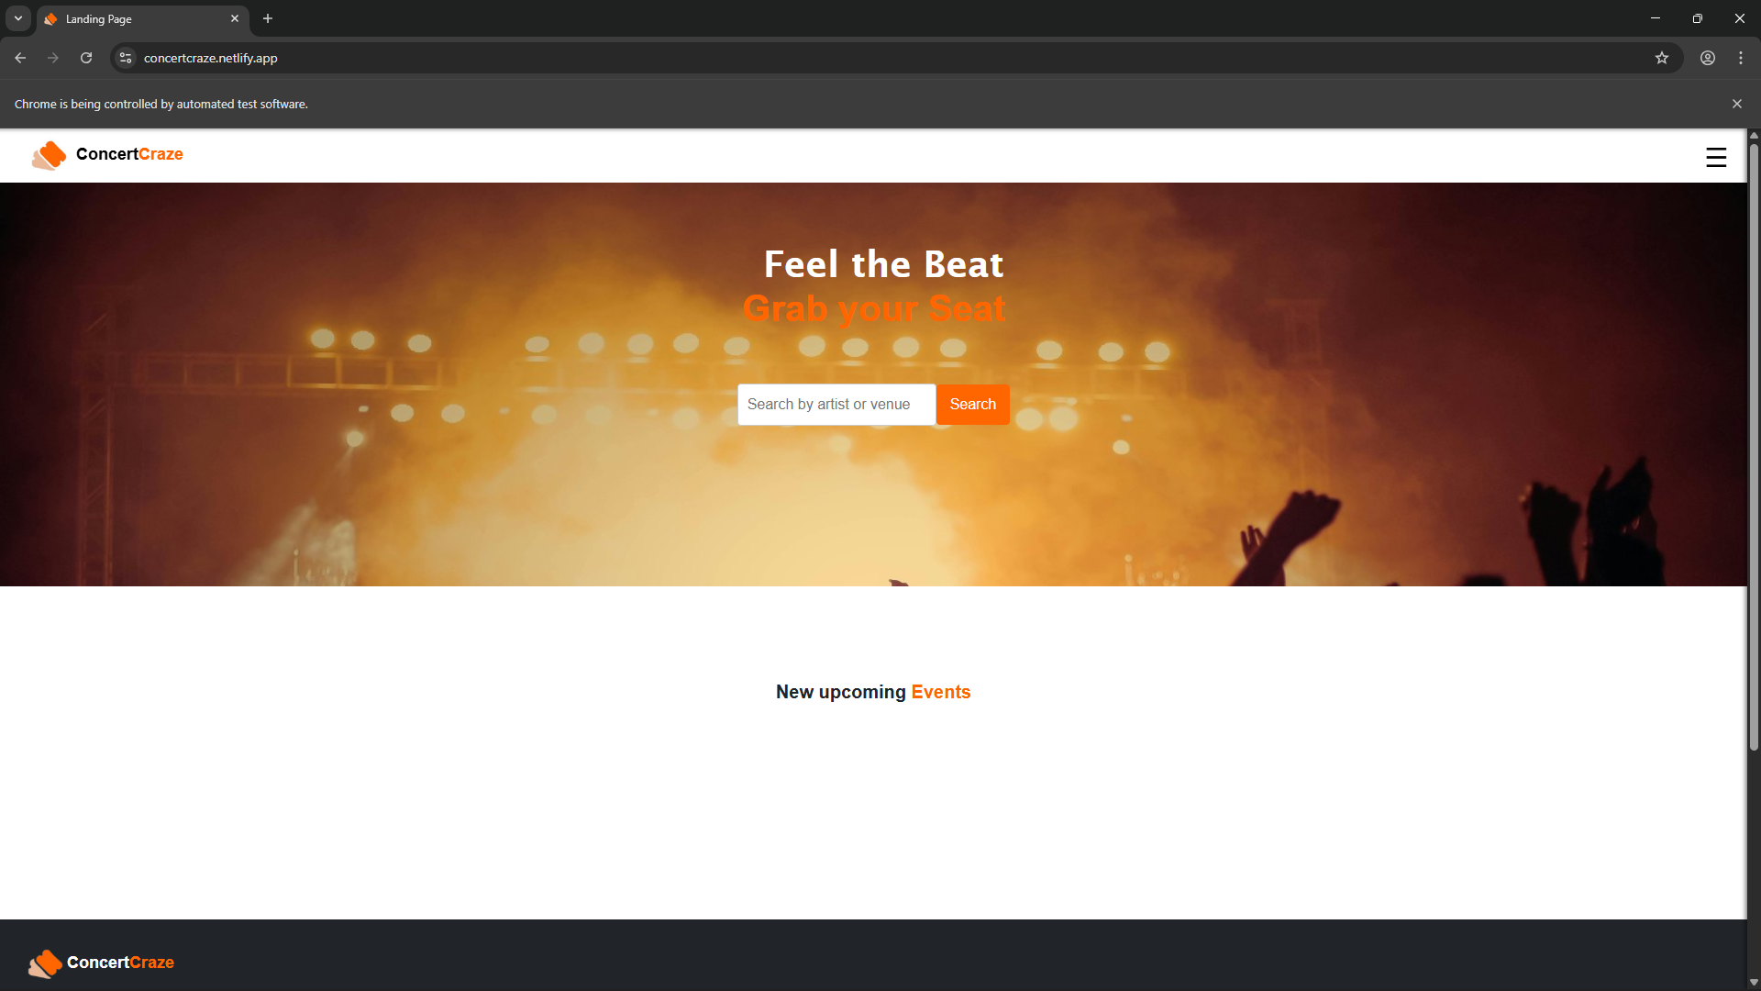

**After completing the testing then it will generate the report**

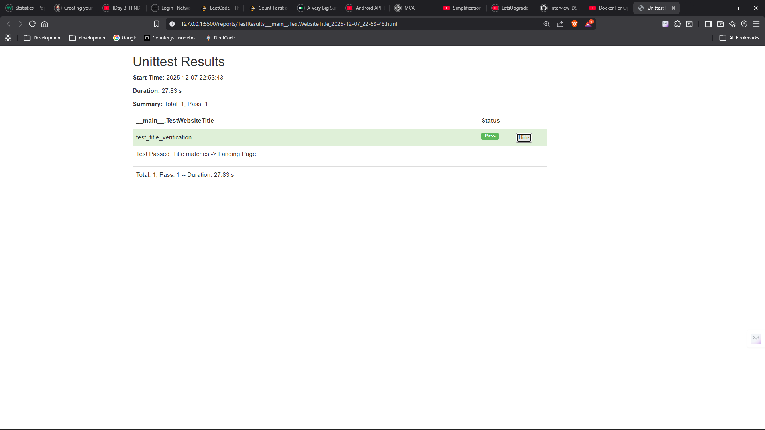

**Practical 6**

Containerization using Docker

**Write in terminal “npm init -y”**

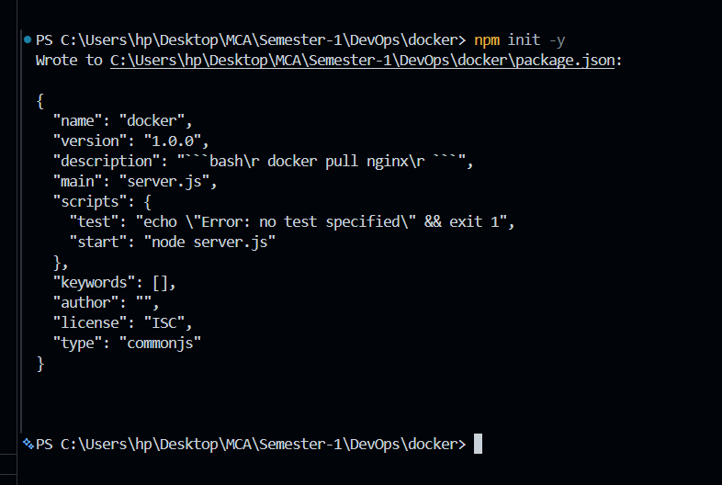

**Create a file “Dockerfile” and write the code**

# Use official Node.js LTS image

FROM node:18

# Create app directory

WORKDIR /app

# Copy package.json (for future npm installs)

COPY package.json .

# Install dependencies (if any in future)

RUN npm install

# Copy rest of the application files

COPY . .

# Expose port used by Node.js

EXPOSE 5000

# Start the application

CMD ["npm", "start"]

**Create .dockerignore (recommended)**

node_modules

npm-debug.log

This keeps the image small.

# ****Build the Docker image****

From inside the project folder run:

docker build -t node-calculator .

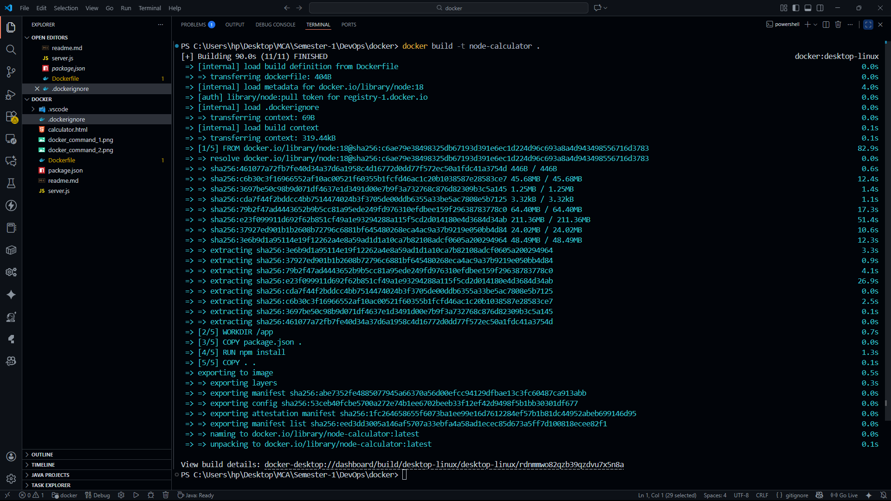

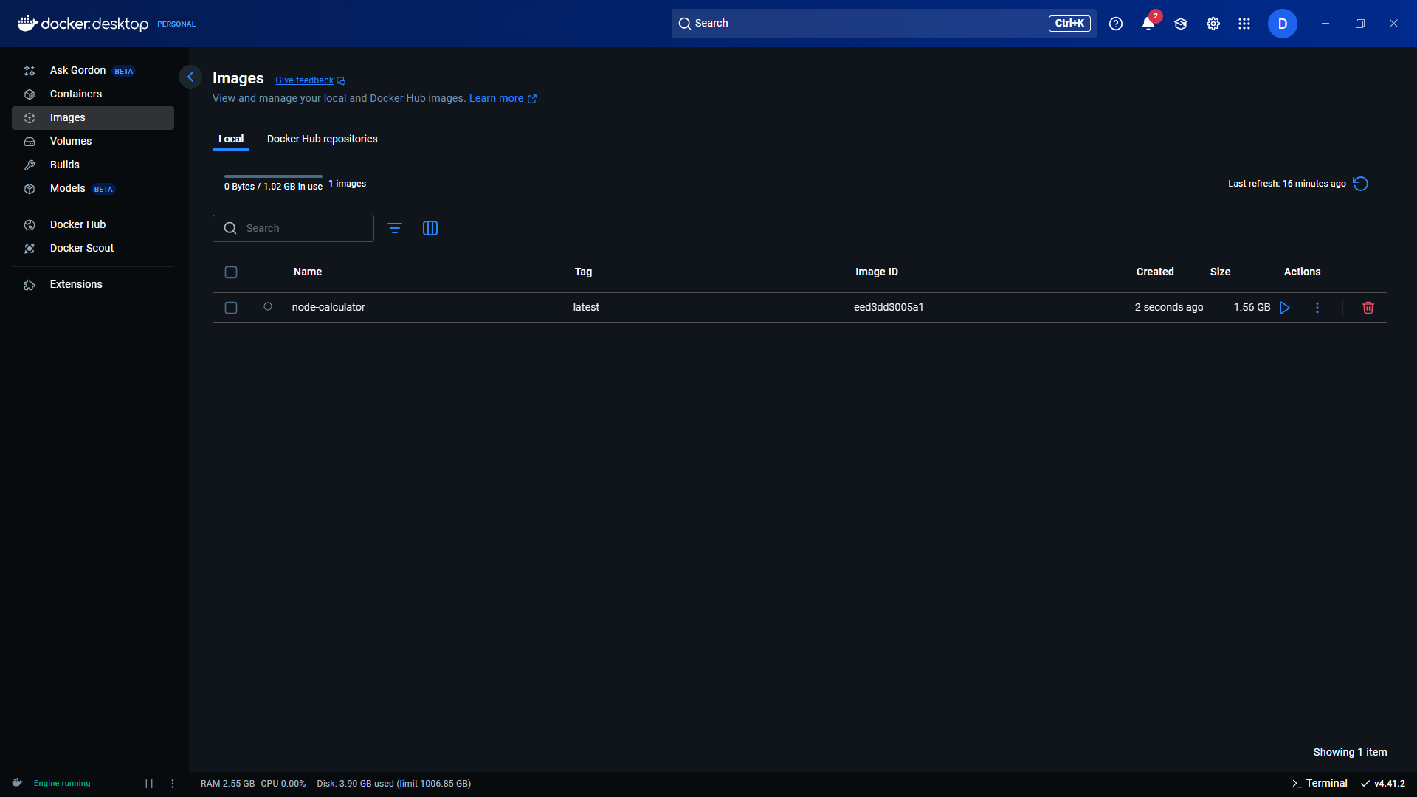

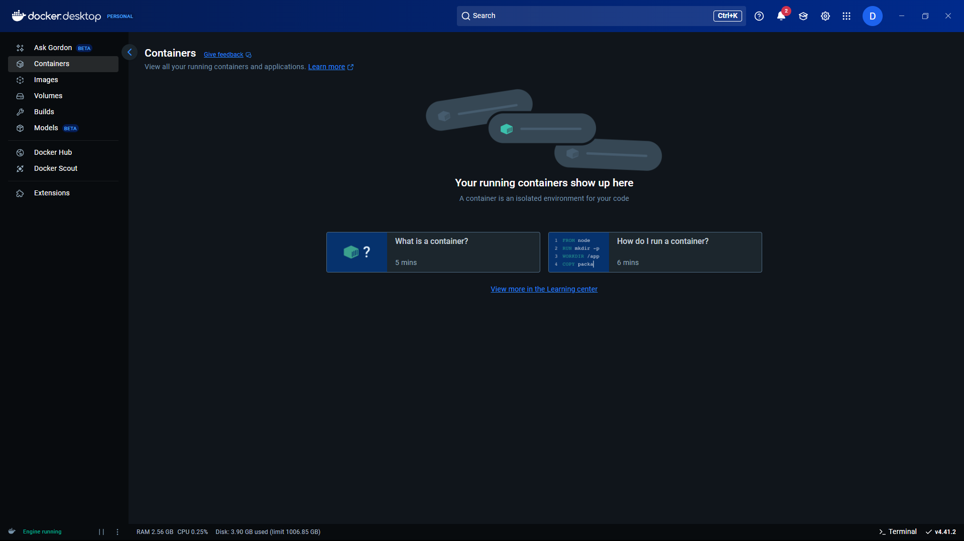

# ****Run the container****

docker run -d -p 5000:5000 --name calc-container node-calculator

Now your server is running inside Docker.

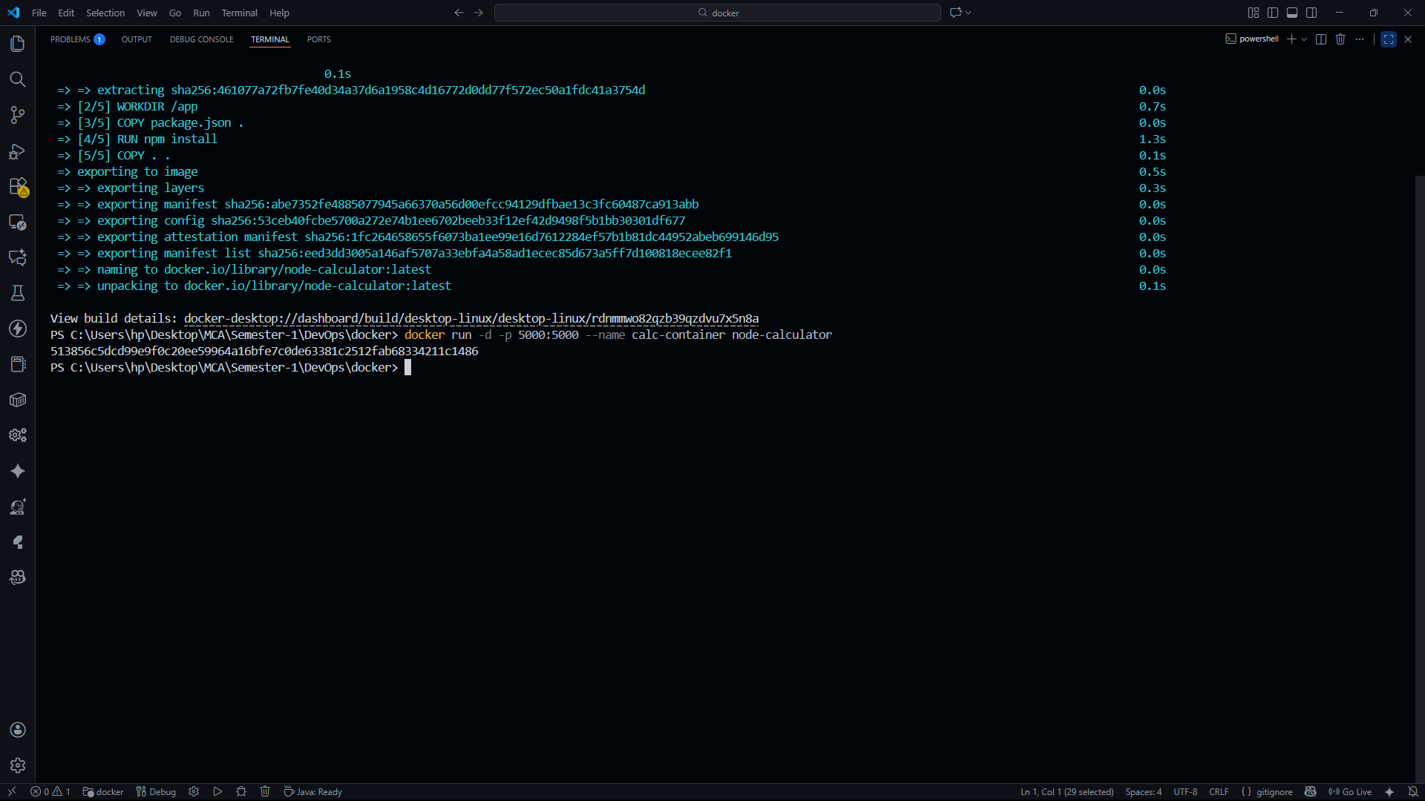

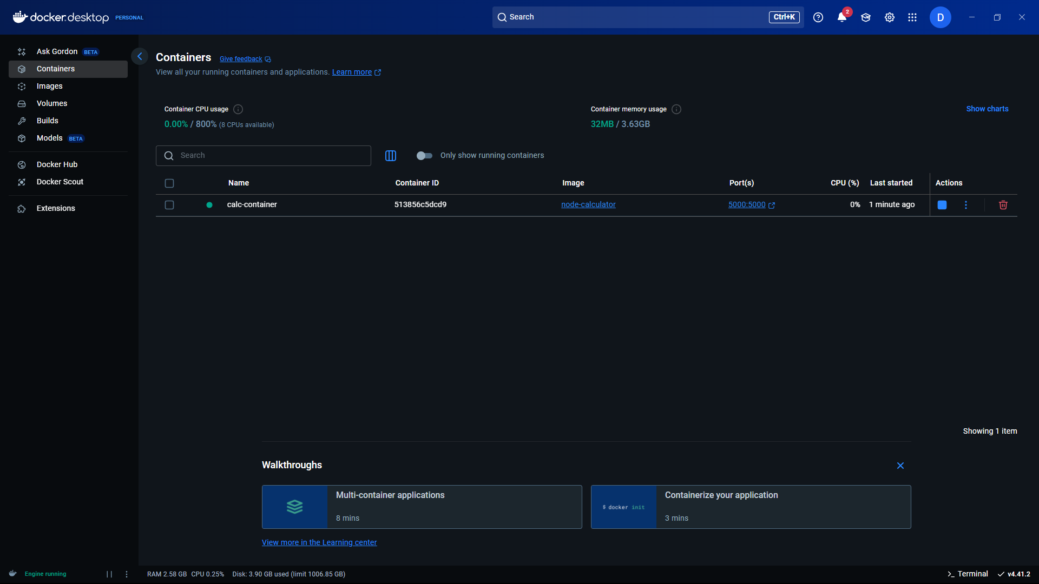

**Now created the container “**calc-container” **Now click on the below of the port 5000:5000**

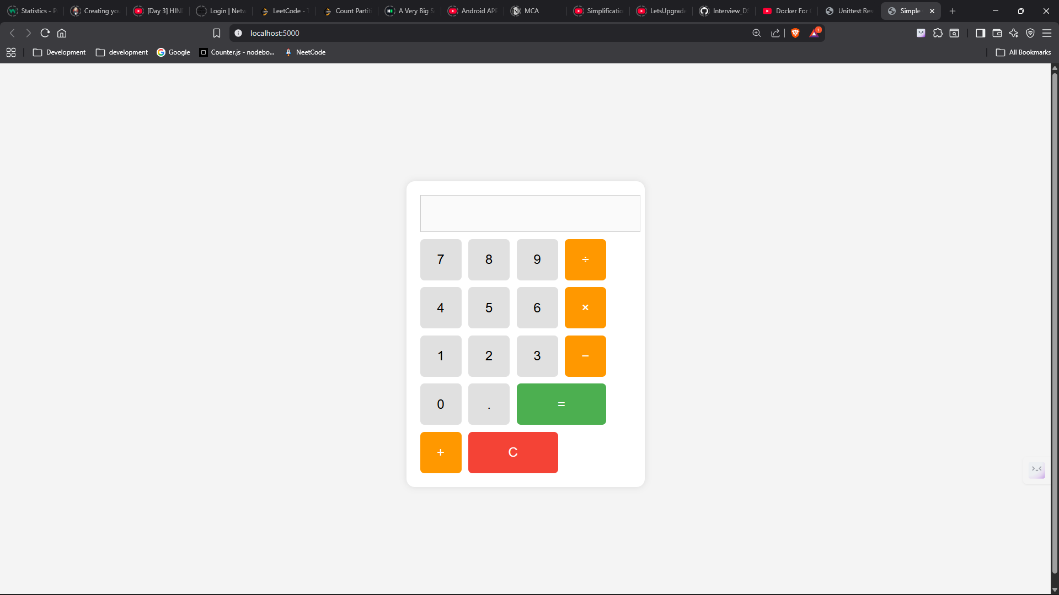

# ****Test the application****

Open in your browser:

http://localhost:5000

You should see **calculator.html** served by your node server from inside Docker.

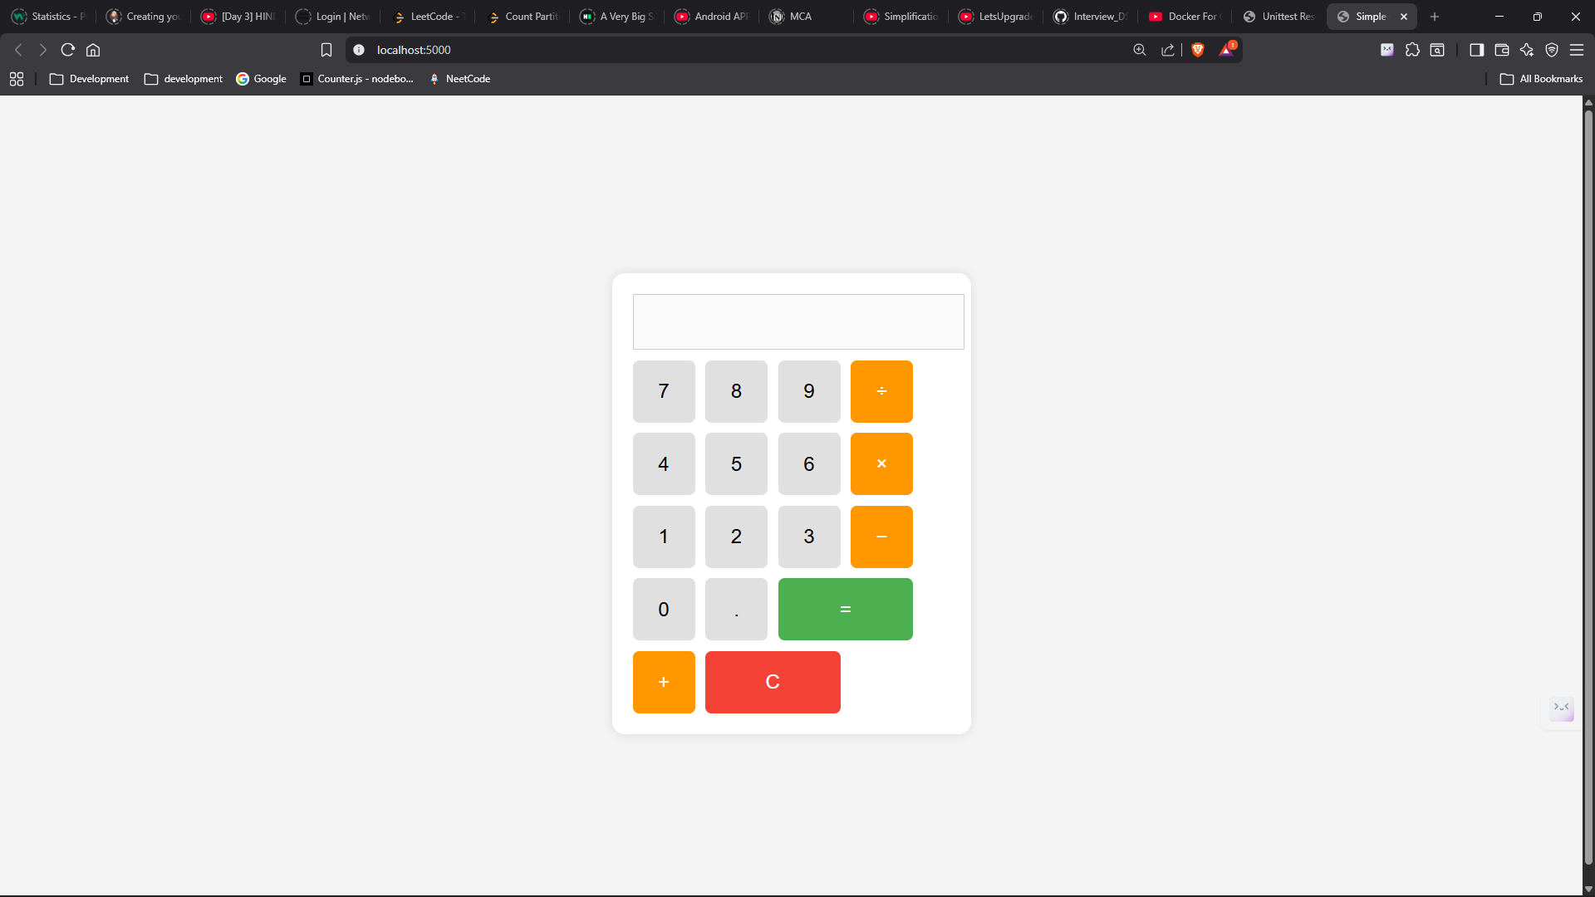

**You can also manually write** <http://localhost:5000>

**Now app is working fine**

# Optional: View logs

docker logs calc-container

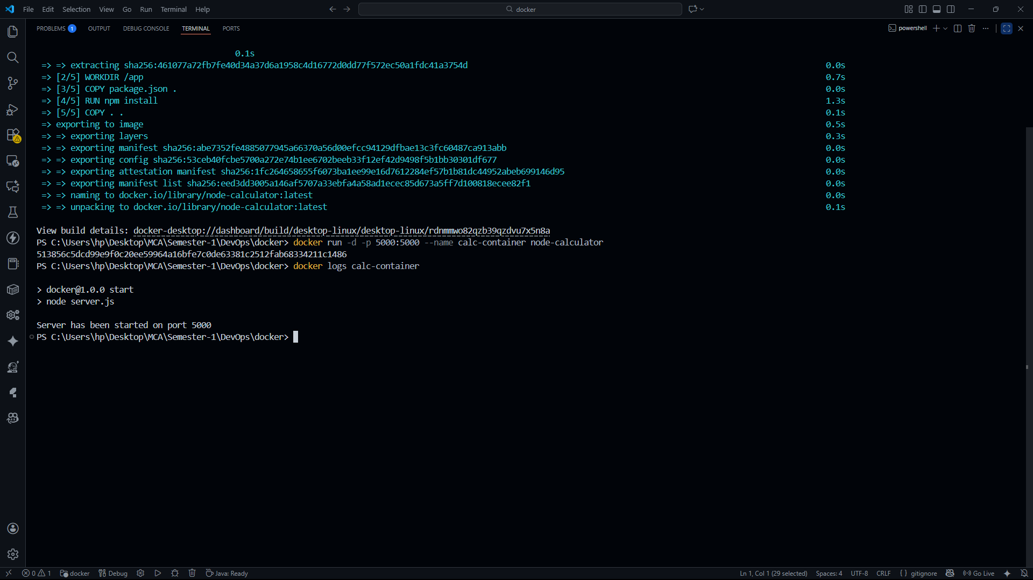

# Optional: Stop & remove container

docker stop calc-container

docker rm calc-container

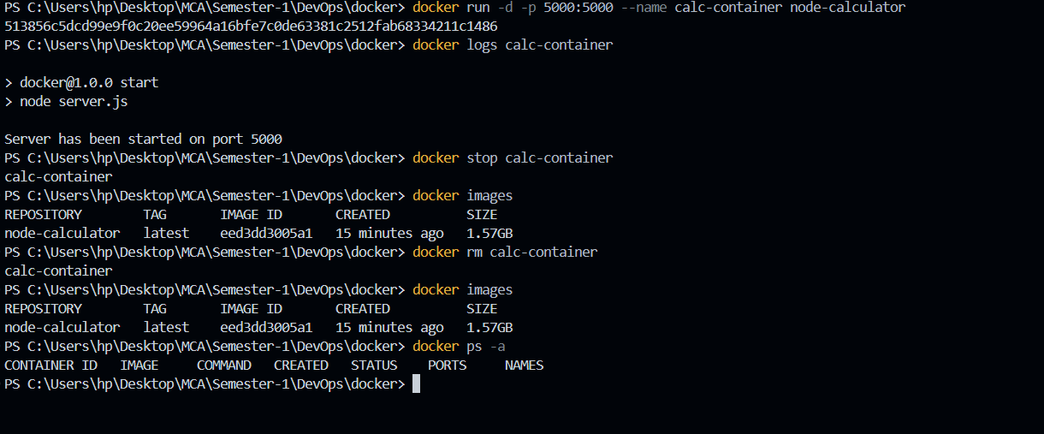

Docker ps -a # it will show all container

Docker images # it will show all images